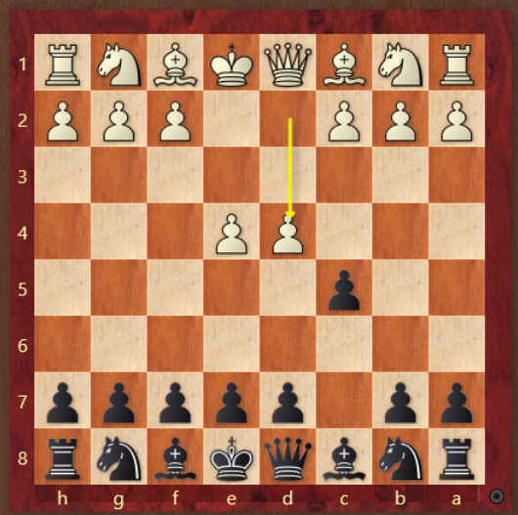 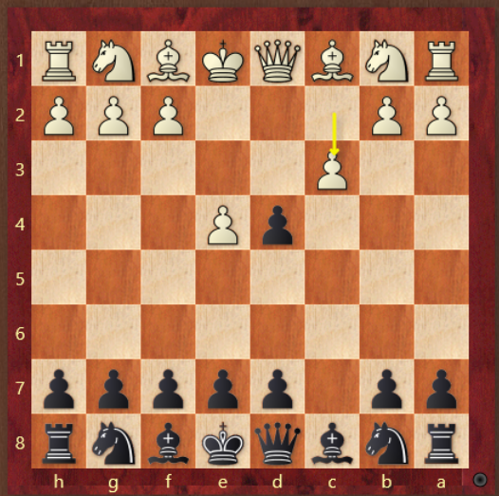

-Smith Morra, cxd4 will transpose -Don’t take the pawn, Nf6!

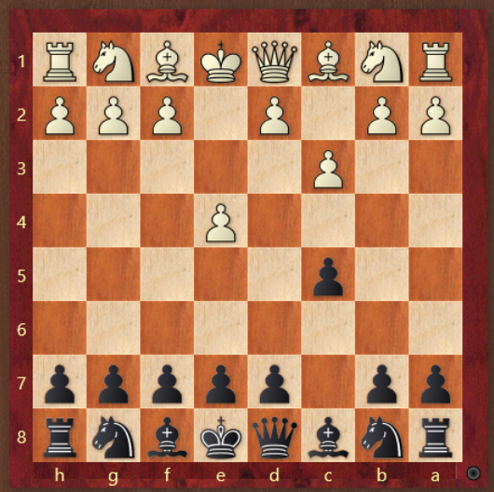 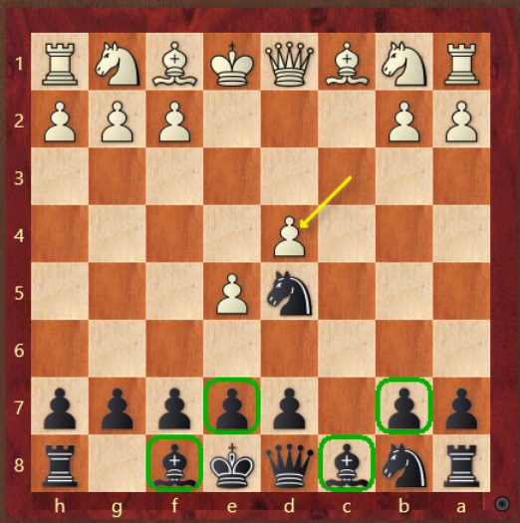

-Nf6! -e6 b6, Ba6 after their LSB moves

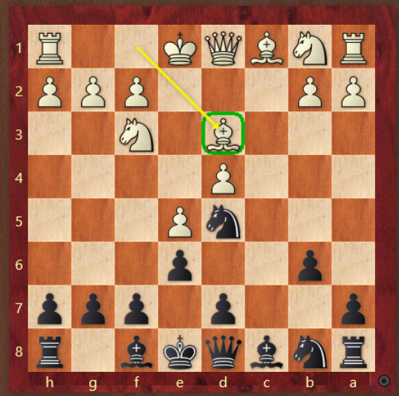 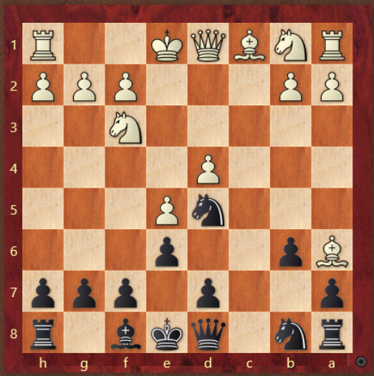

-LSB moved, Ba6 -Bb4! Then Nxa6, eventually d6

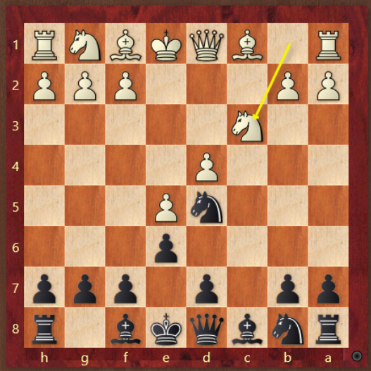 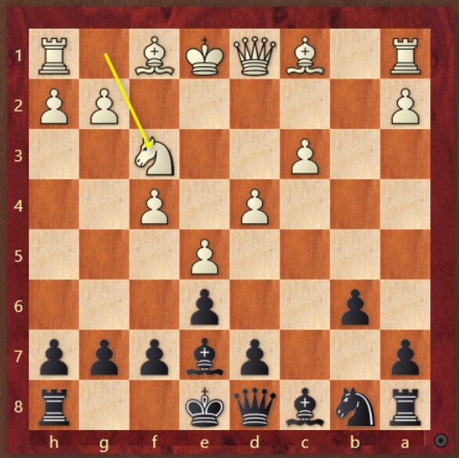

-Nxc3 Qc7 and poke the pawn -Qc7, Ba6 after LSB moves