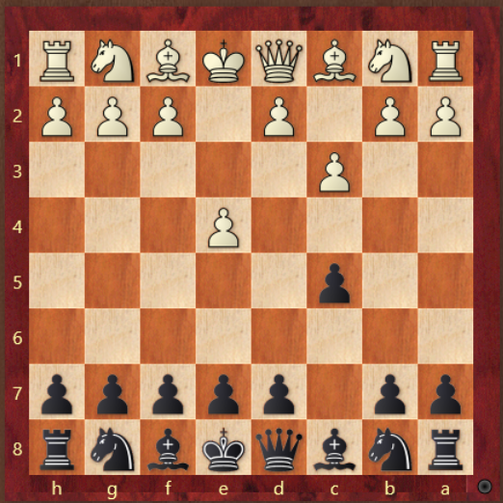 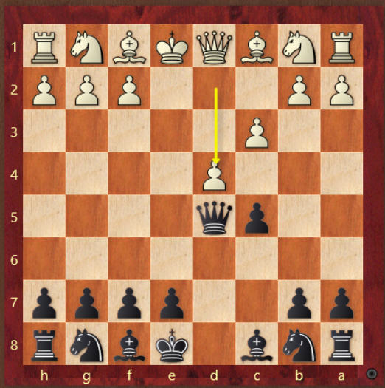

-d5! Qxd5 -e6! If dxc5 Qxd1 Bxc5

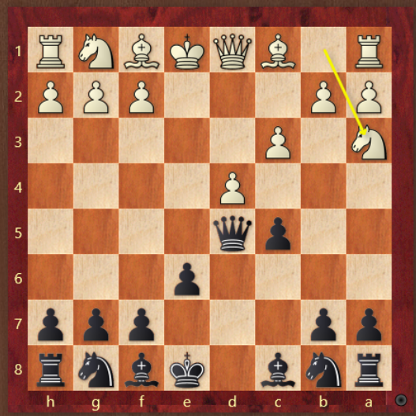 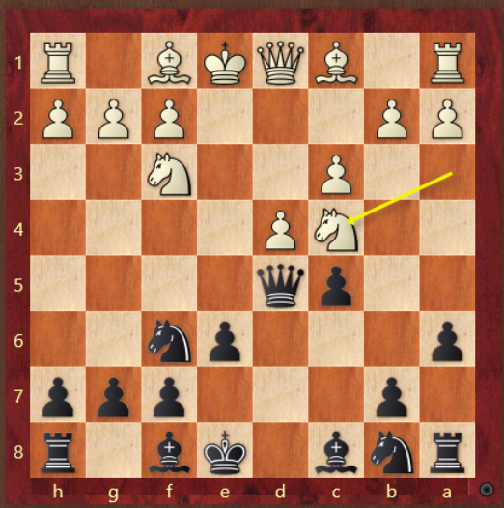

-Prevent Nb5 w/ a6 -Nd7 prevent Nb6(b5 coming)

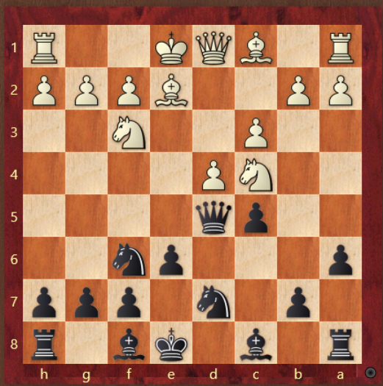 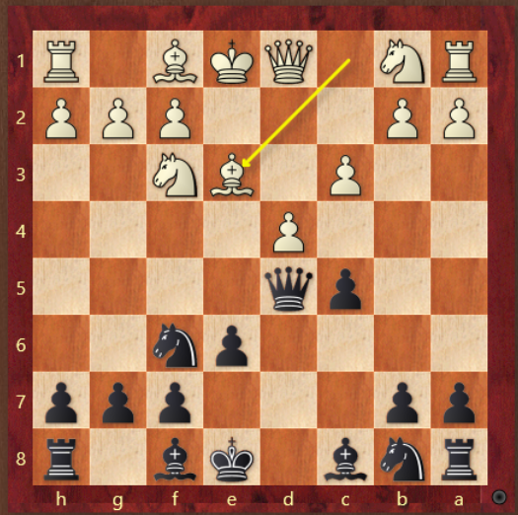

-b5 Ne3 Qc6 black chillin -Be7,dxc5 0-0! Trade knight for DSB

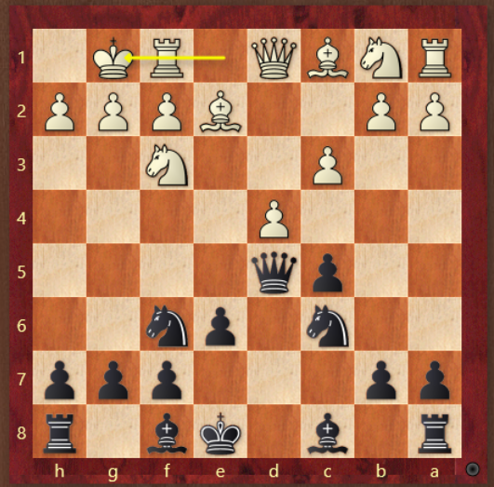 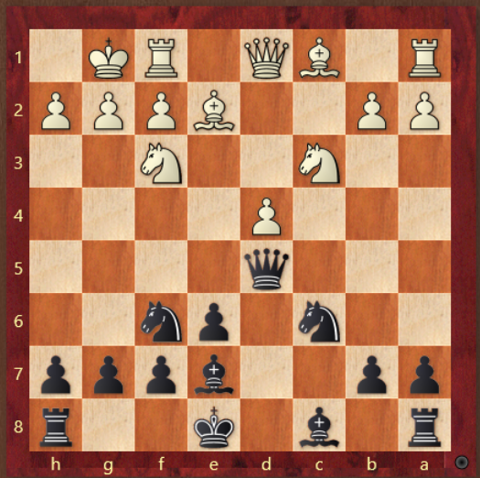

-cxd4 great IQP position -Qd6,Nb5,Qd8 Bf4 Nd5!