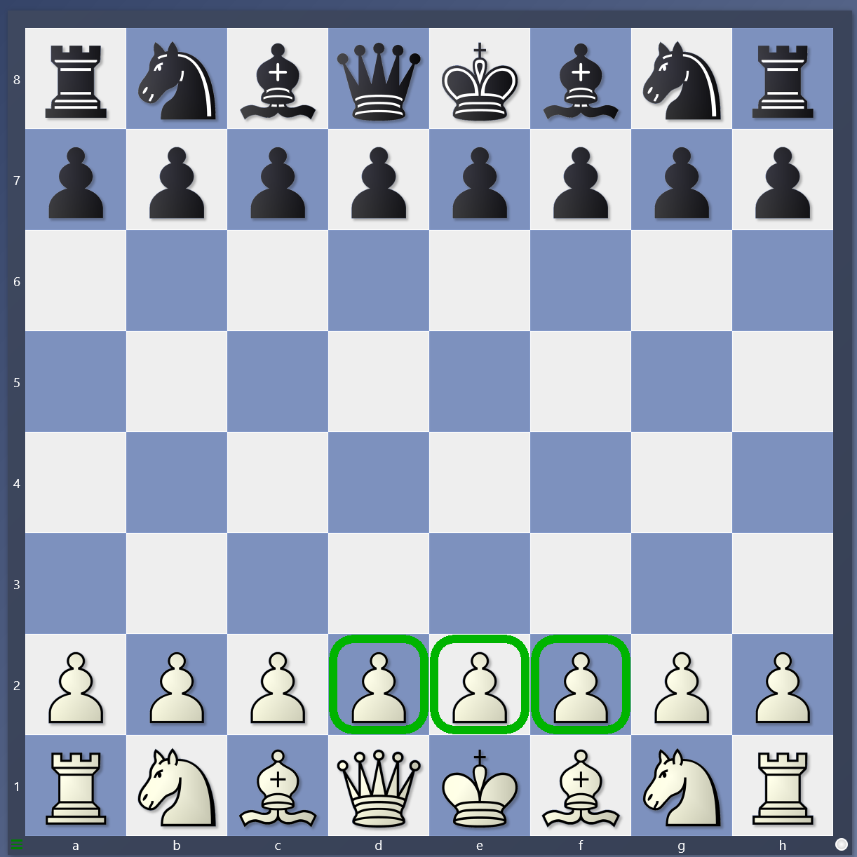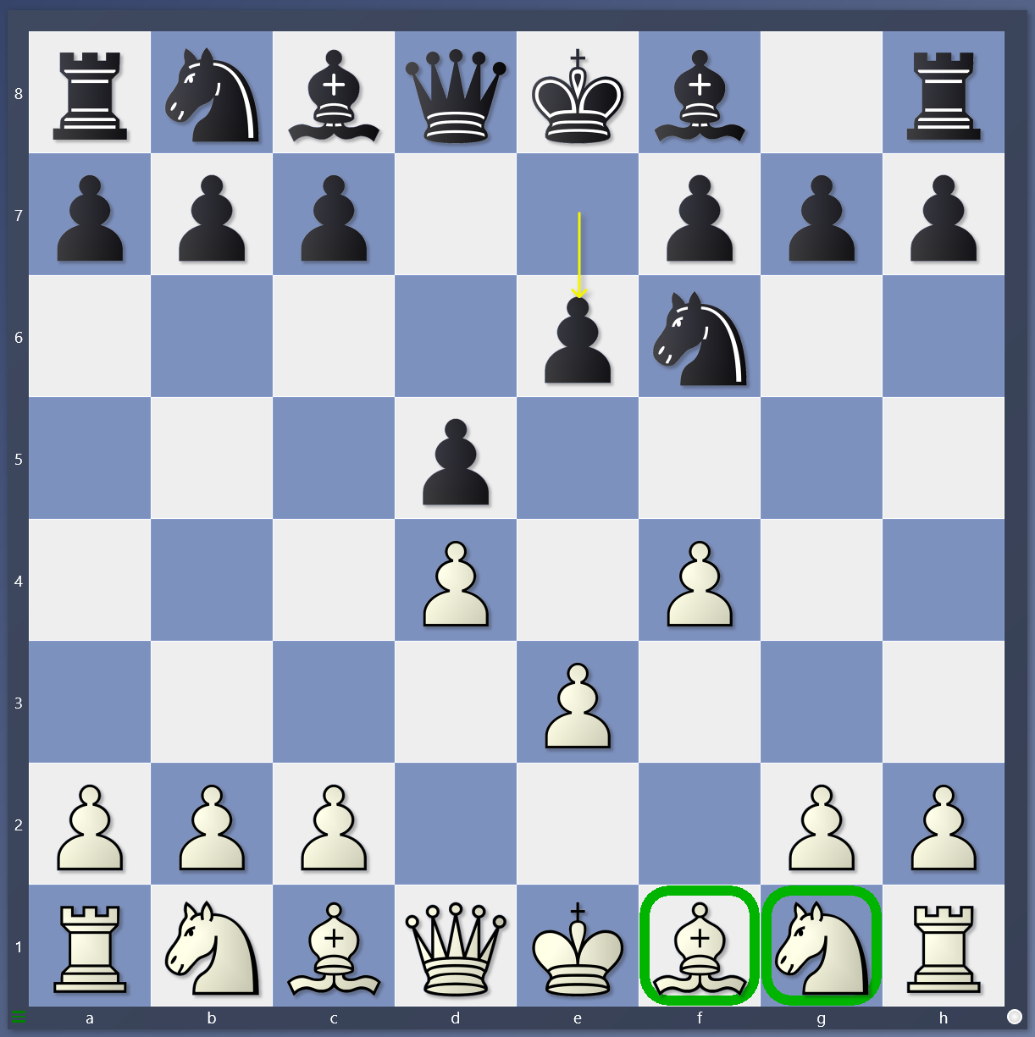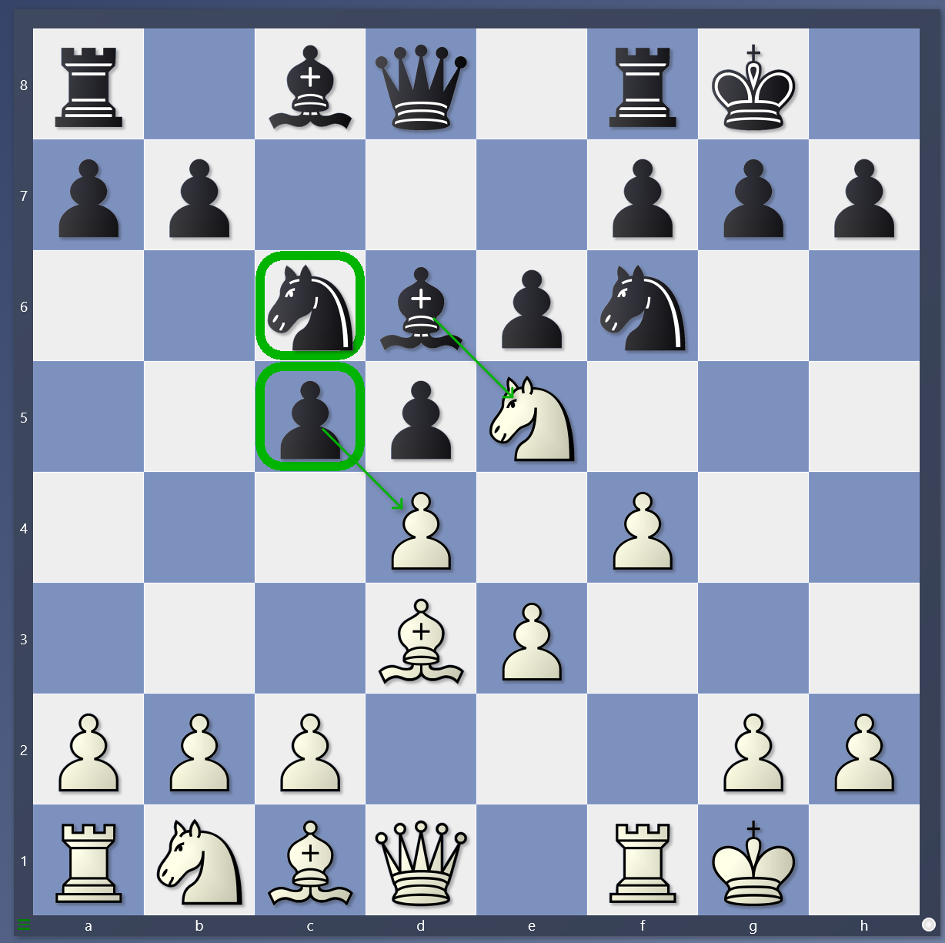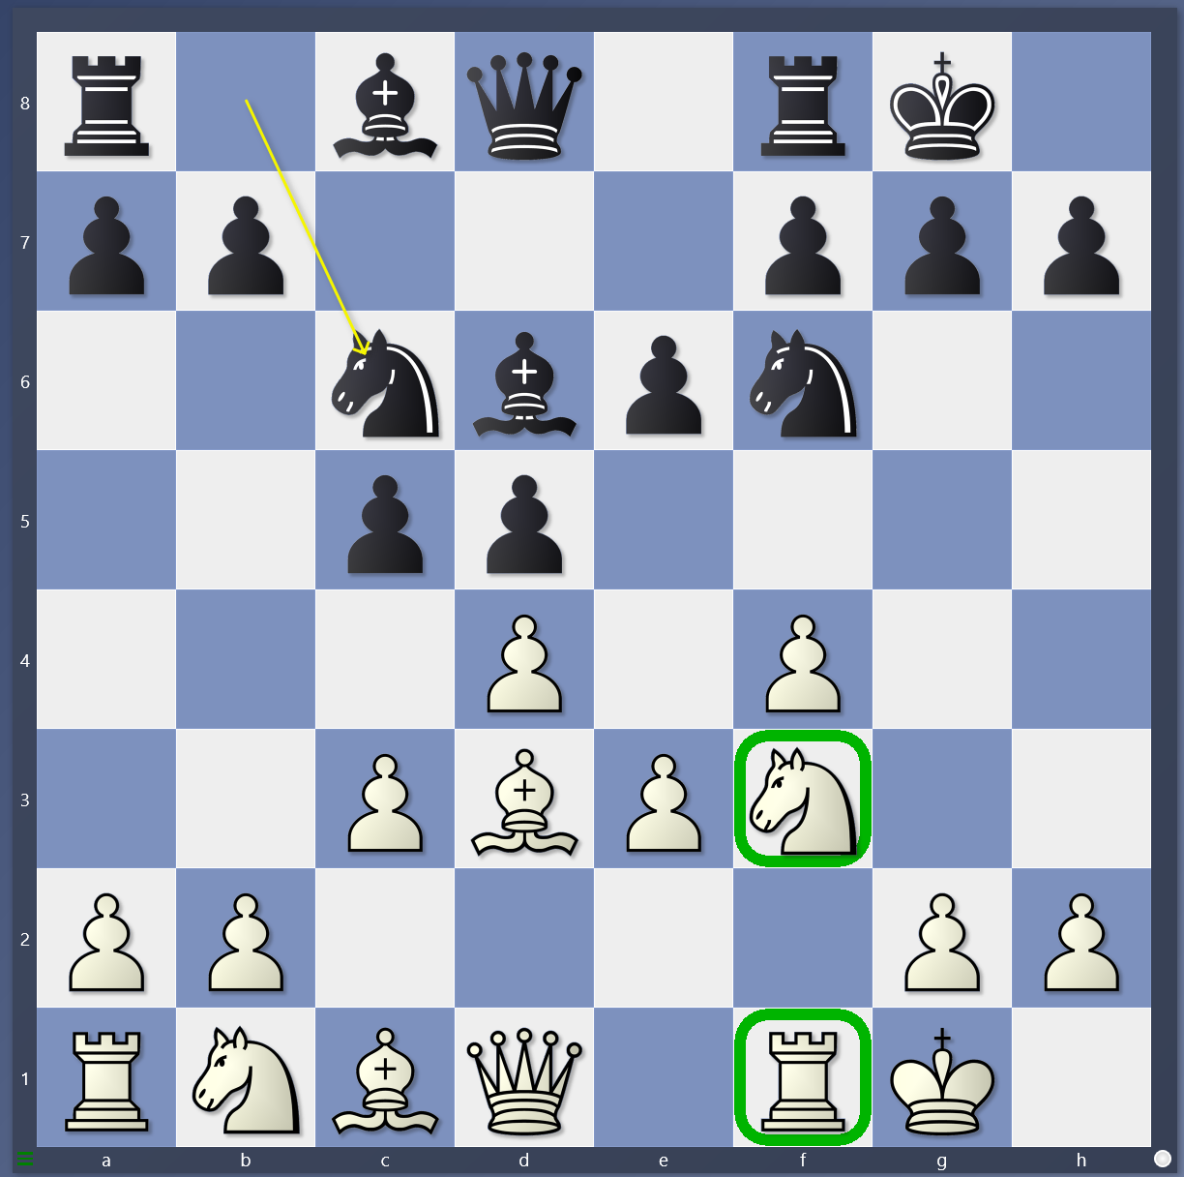

1.What are the first 3 moves for white? In what order? How many squares? Arrows!

2.What comes out first, knights or bishops? In the opening what is your goal? Arrows!

3. If Nc6 or c5, what should white do? If cxd4 how does white capture back? If Bishop takes e5, how does white capture back? Draw Arrows

4. How does white outpost? How does white rook lift? Draw arrows.