**Problem Set 1**

-Bottom side to play

-Follow the directions

-Answer all the questions to the best, write your answers down

**Attacking**

Queen sac

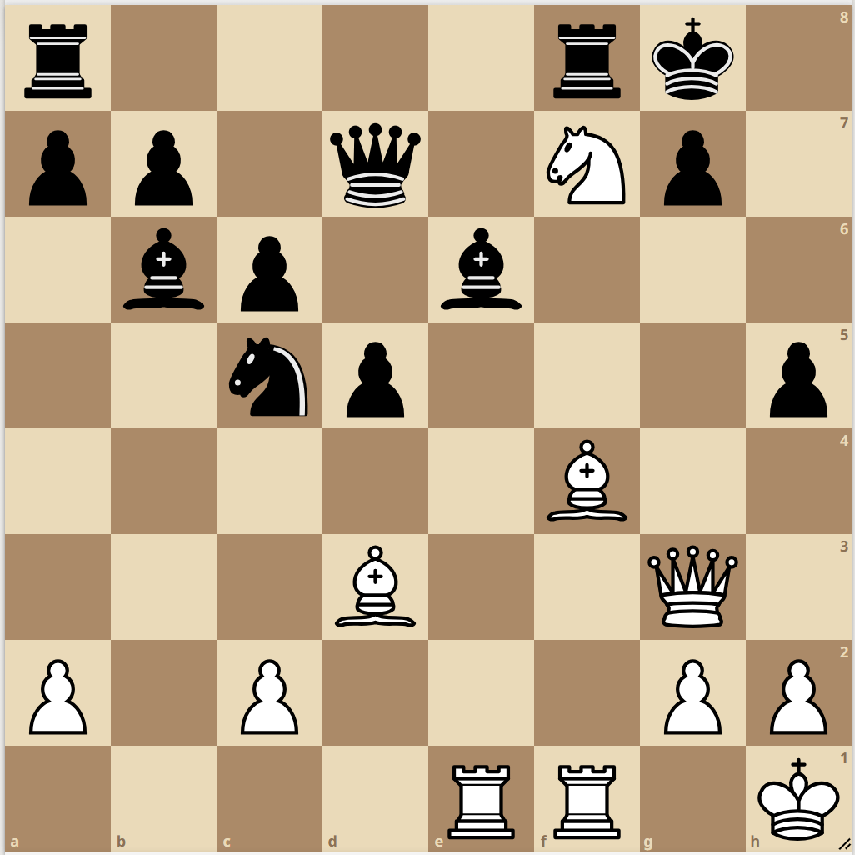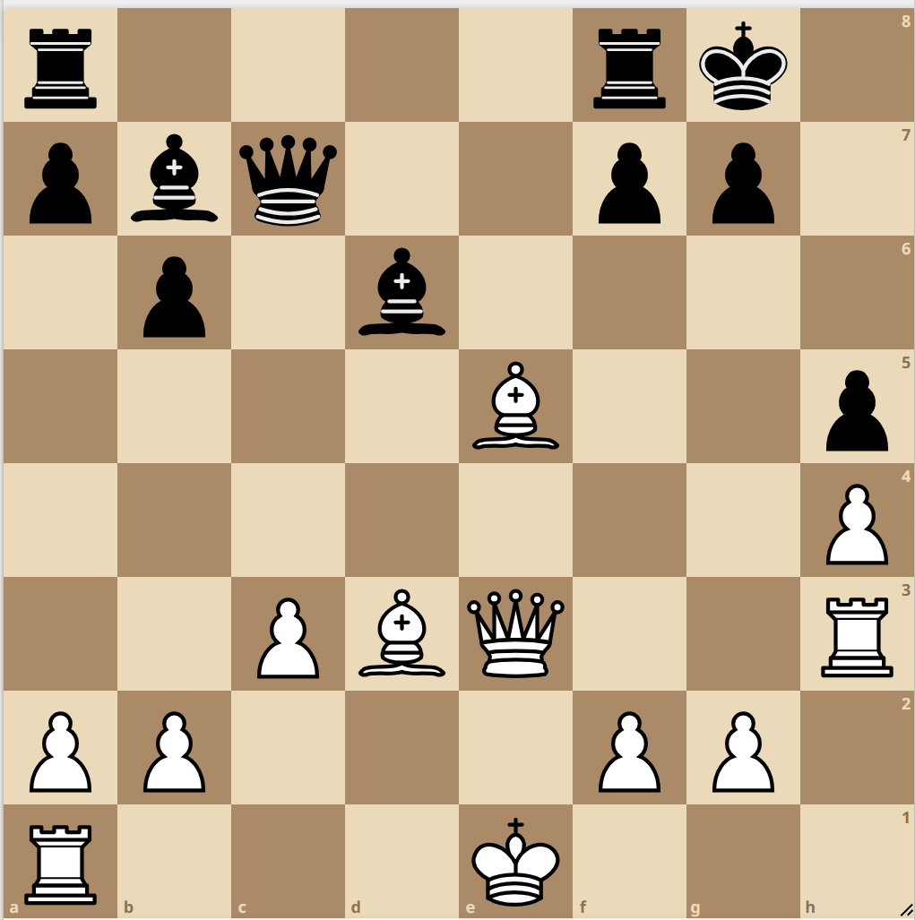

Rook sac

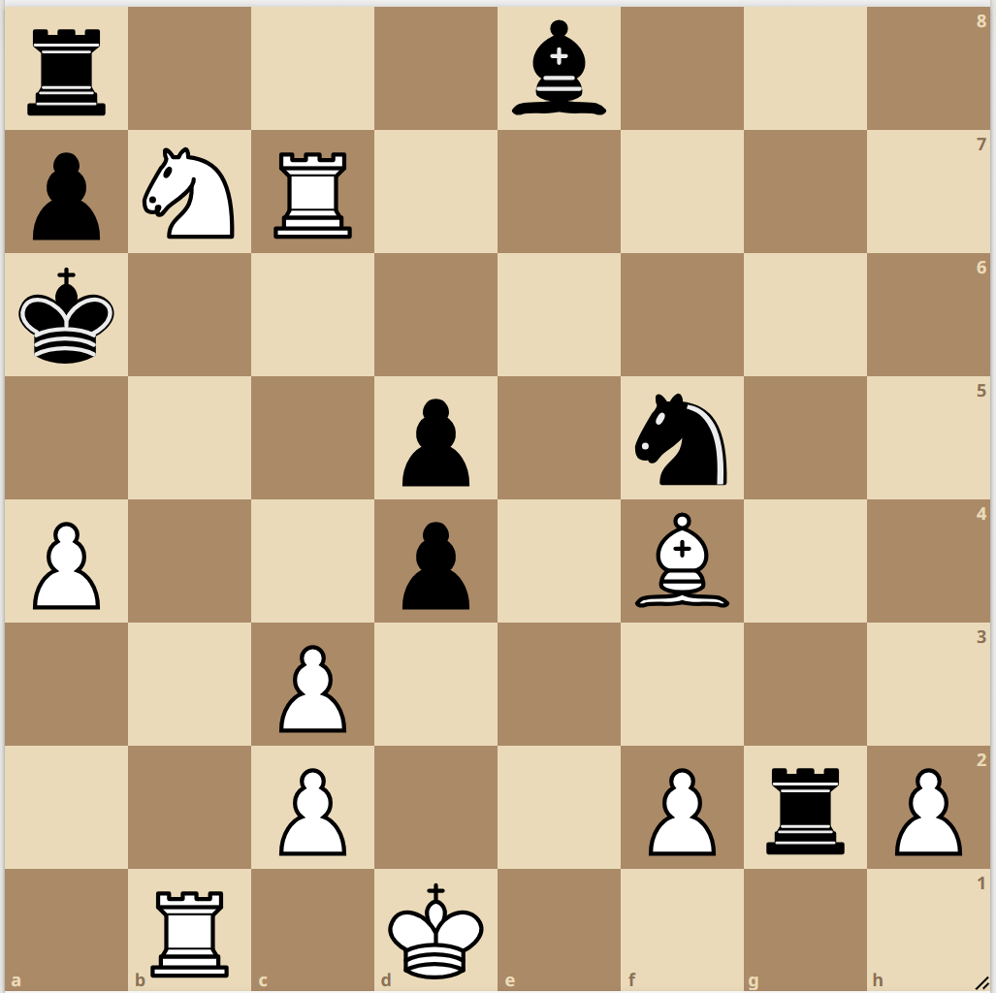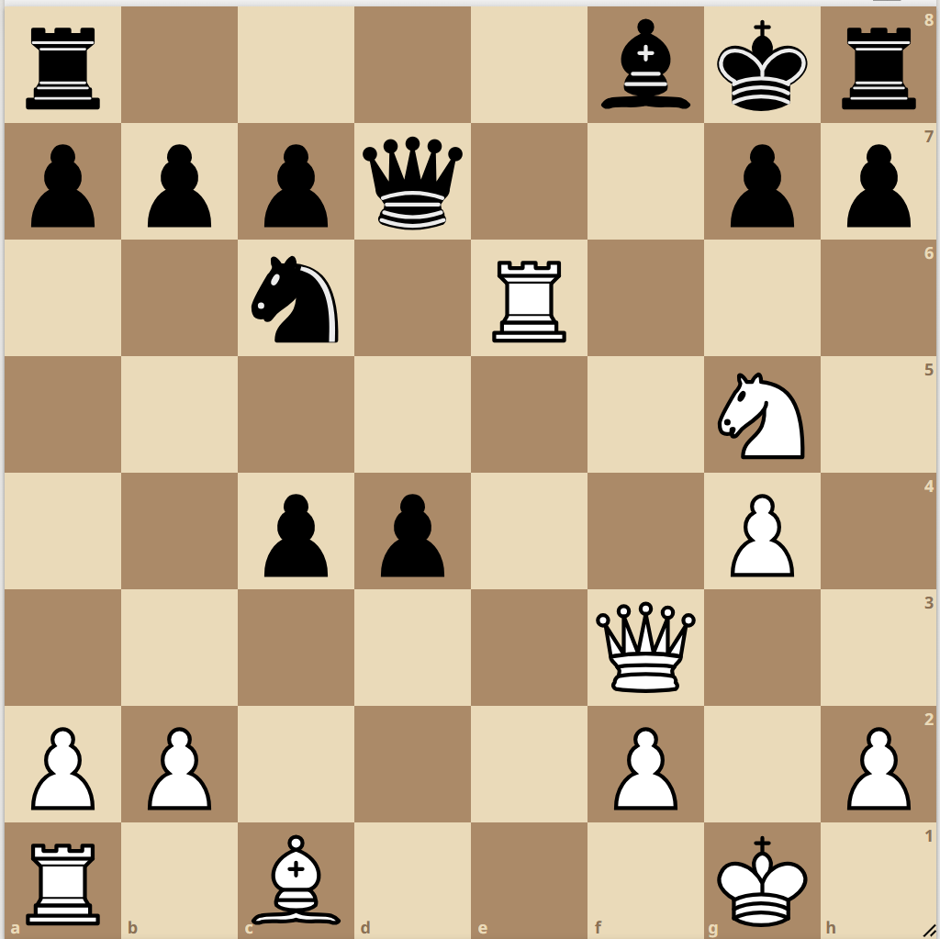

Bishop sac

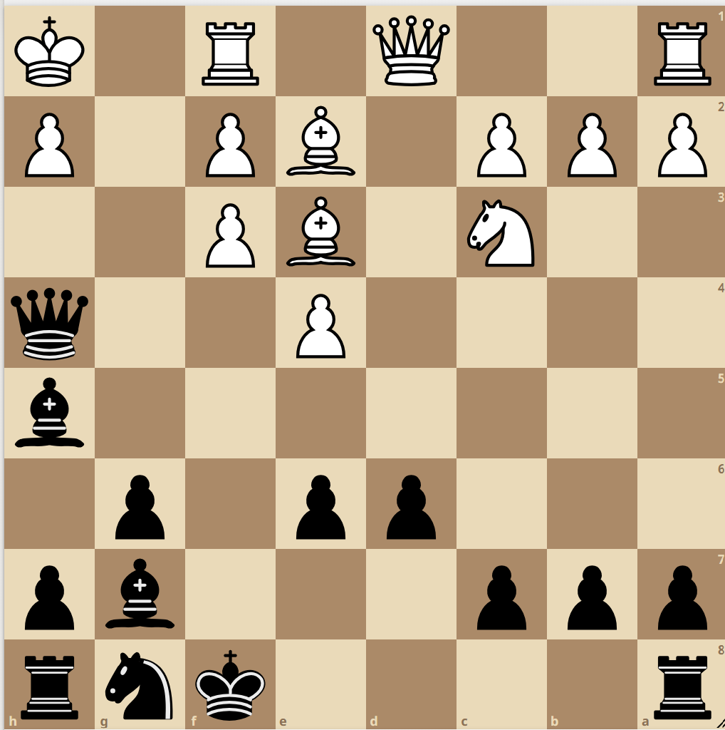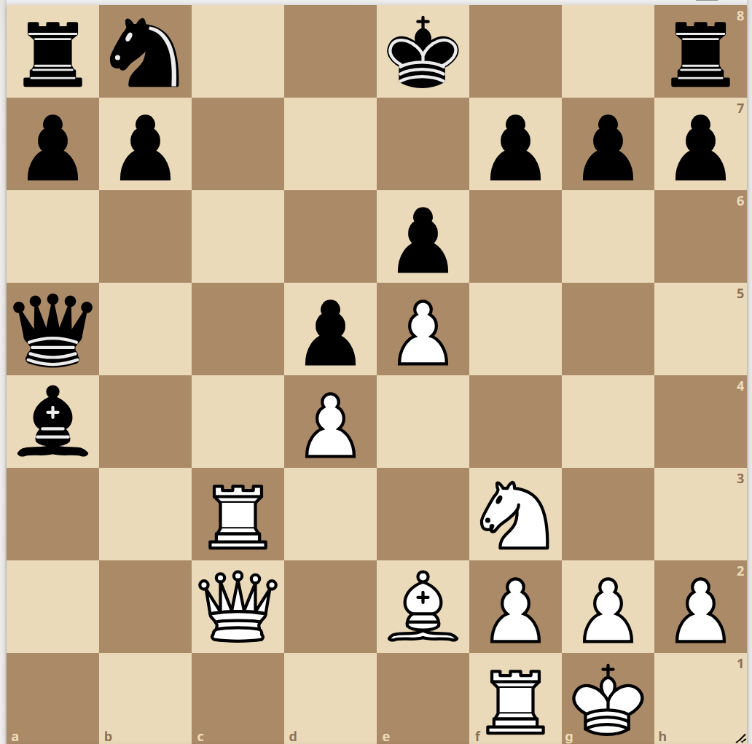

Knight sac

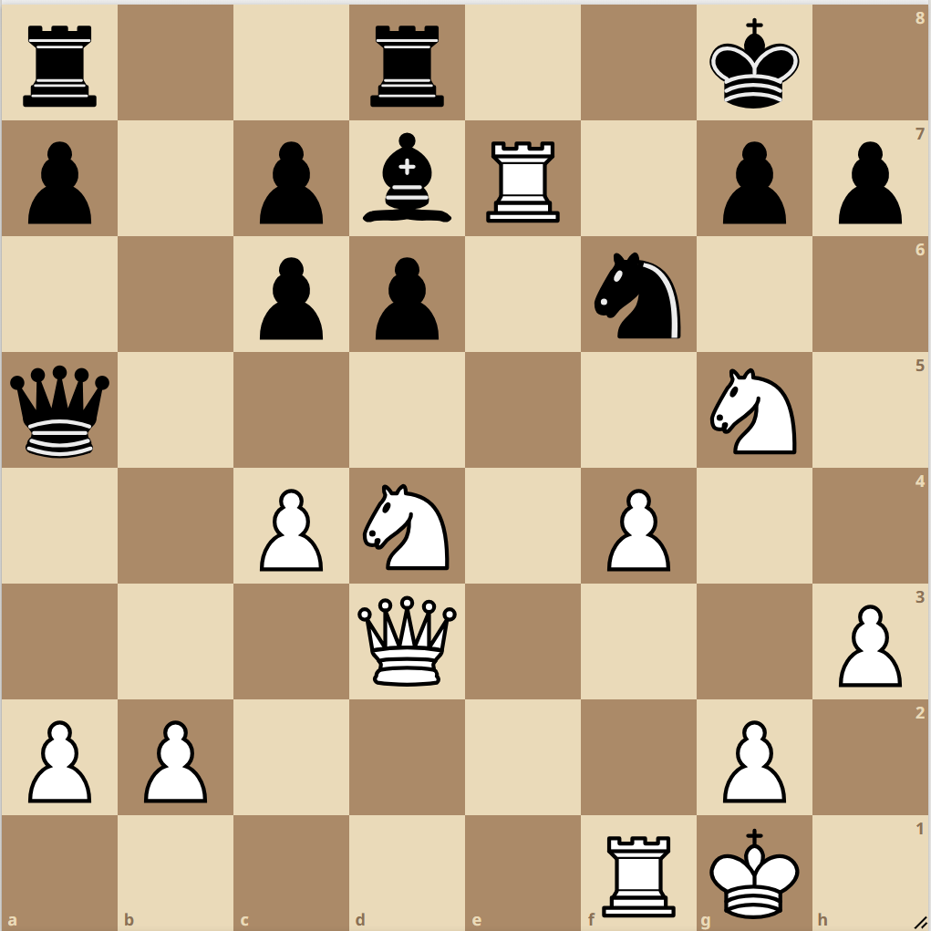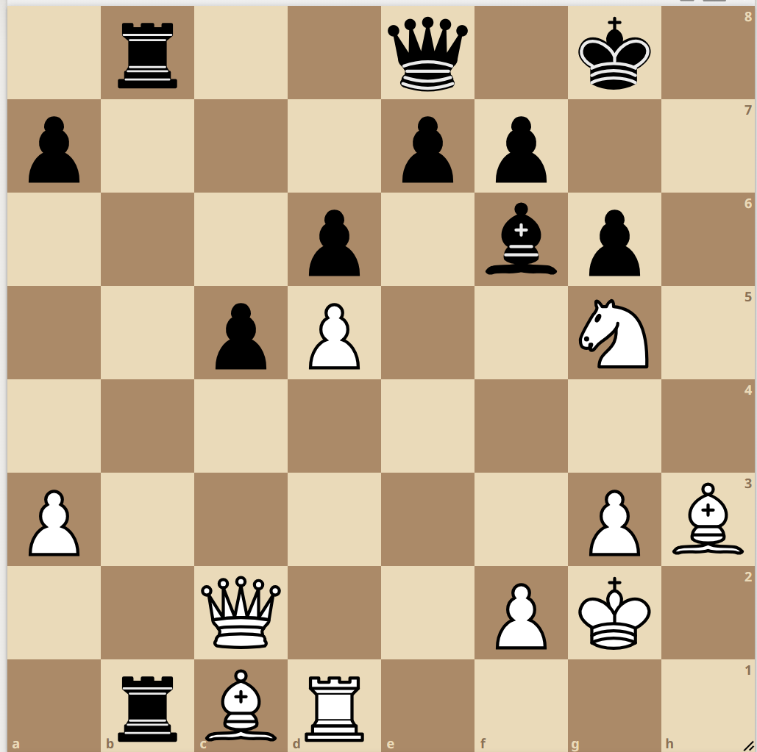

Pawn sac

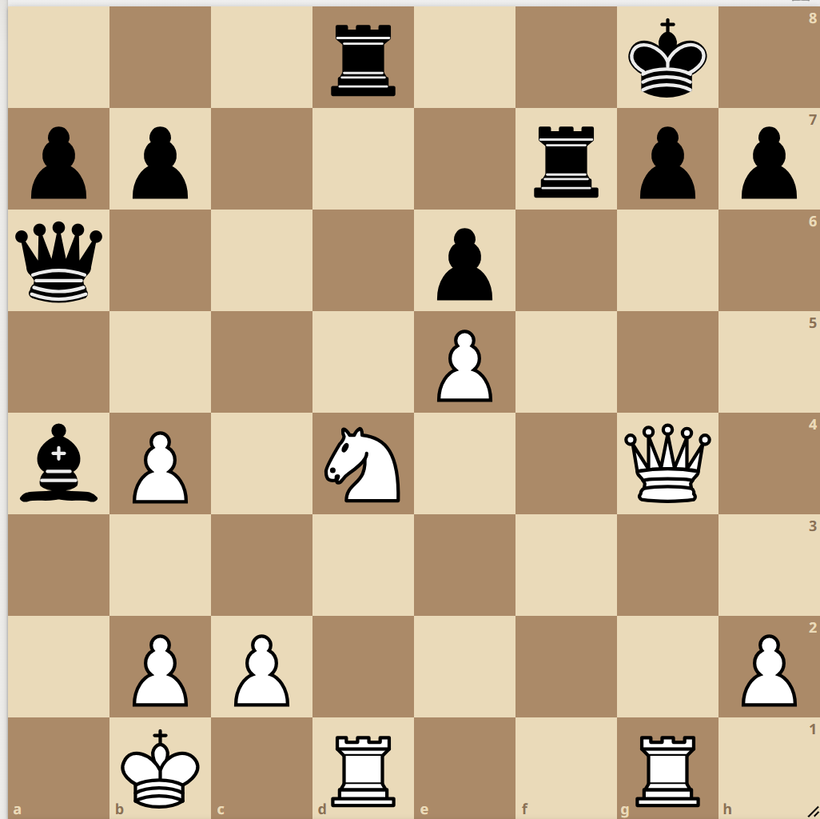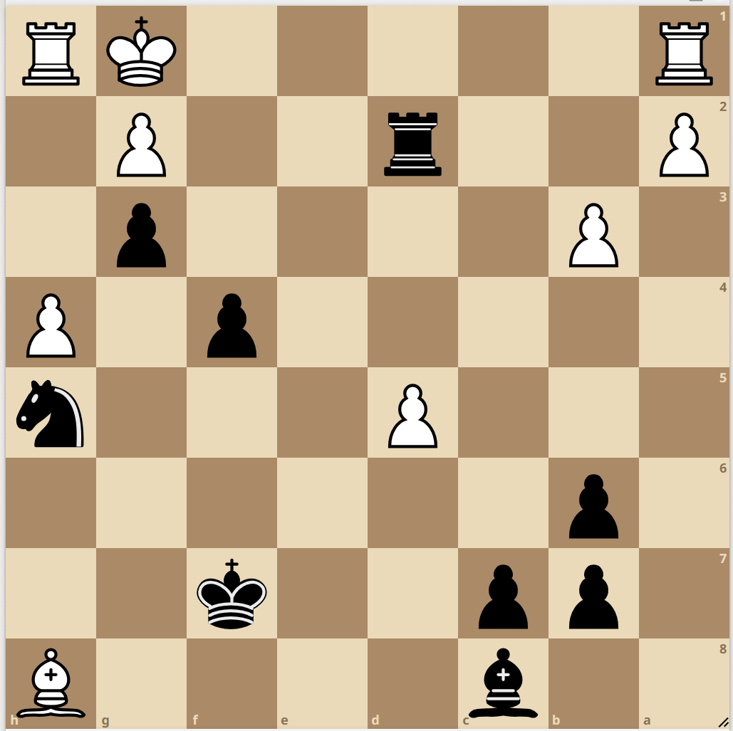

**Opening**

What is the plan for white? If you can’t outpost, what should white do?

When do you go to Nd2? Where is the strongside?  
Where is your strongside? How does white develop?  
When should you not push e4?

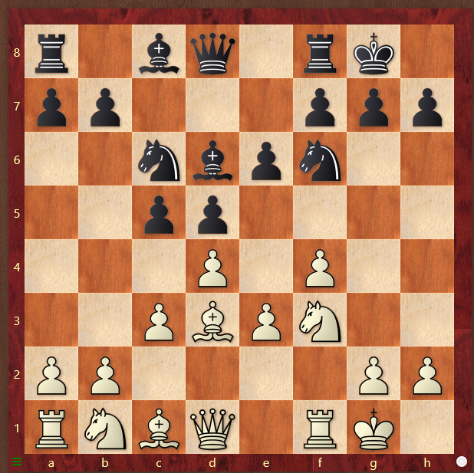 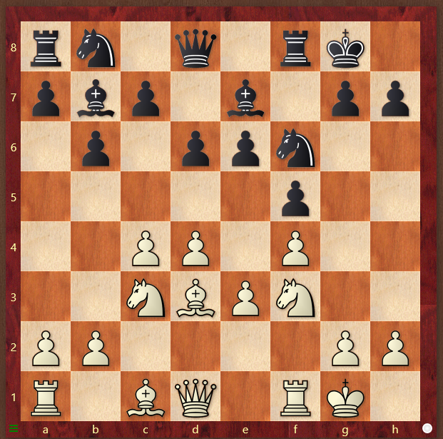

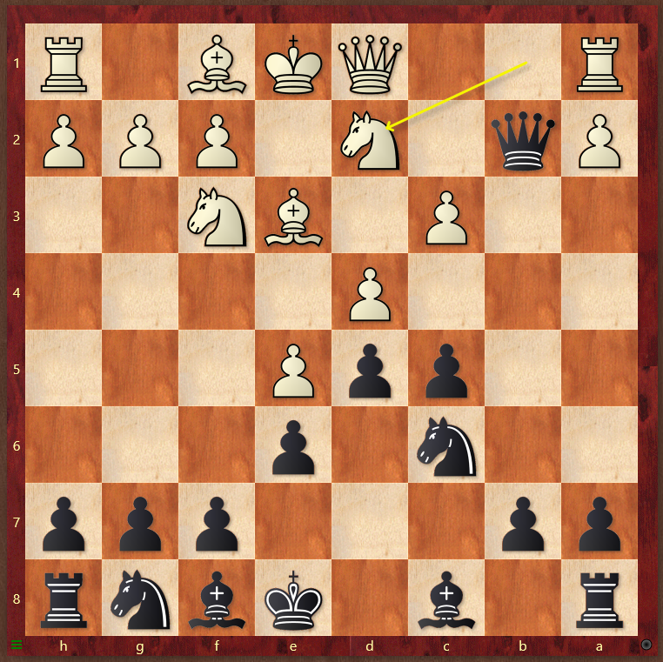 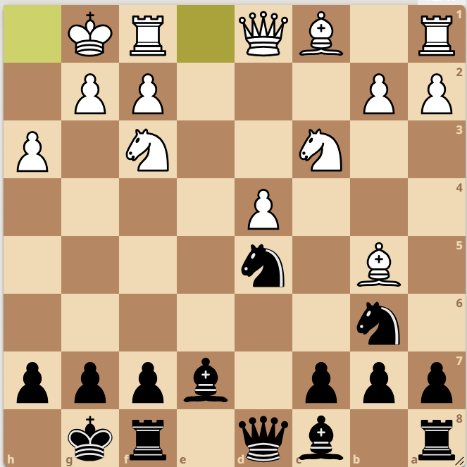

Should black capture on c3? What is the plan against the IQP?

What is white’s most dangerous piece? Trade or no trade?

How do you take away opponents Endgame or middlegame?

Counterplay? Bishop pair good or bad in this position?

White play, win or draw? White to play win or draw?

**Endgame**

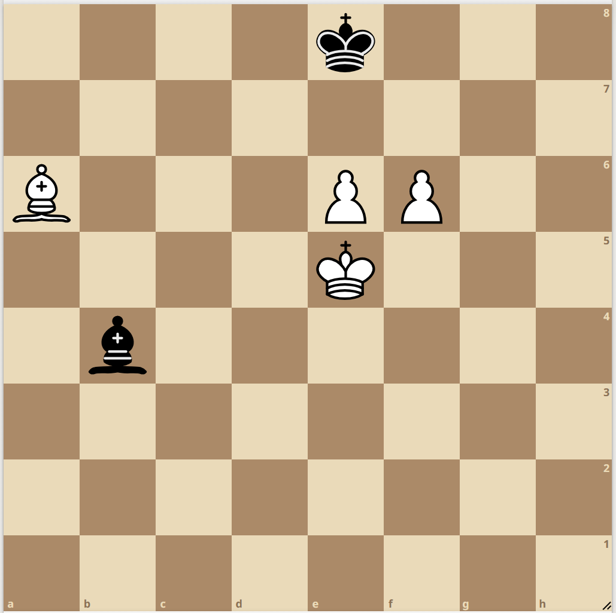 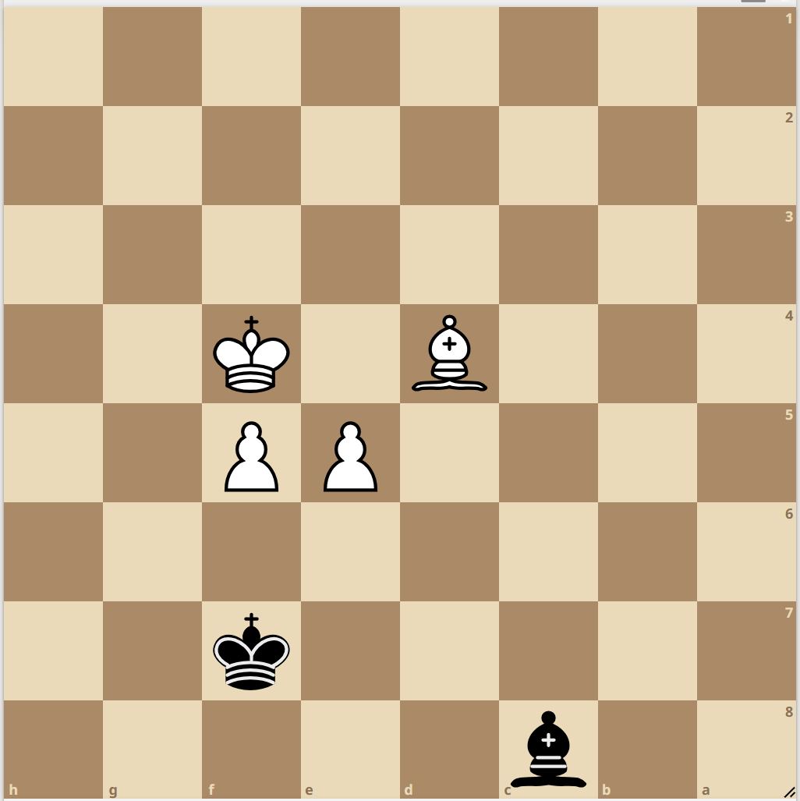

White to play, win or draw? White to play win or draw?

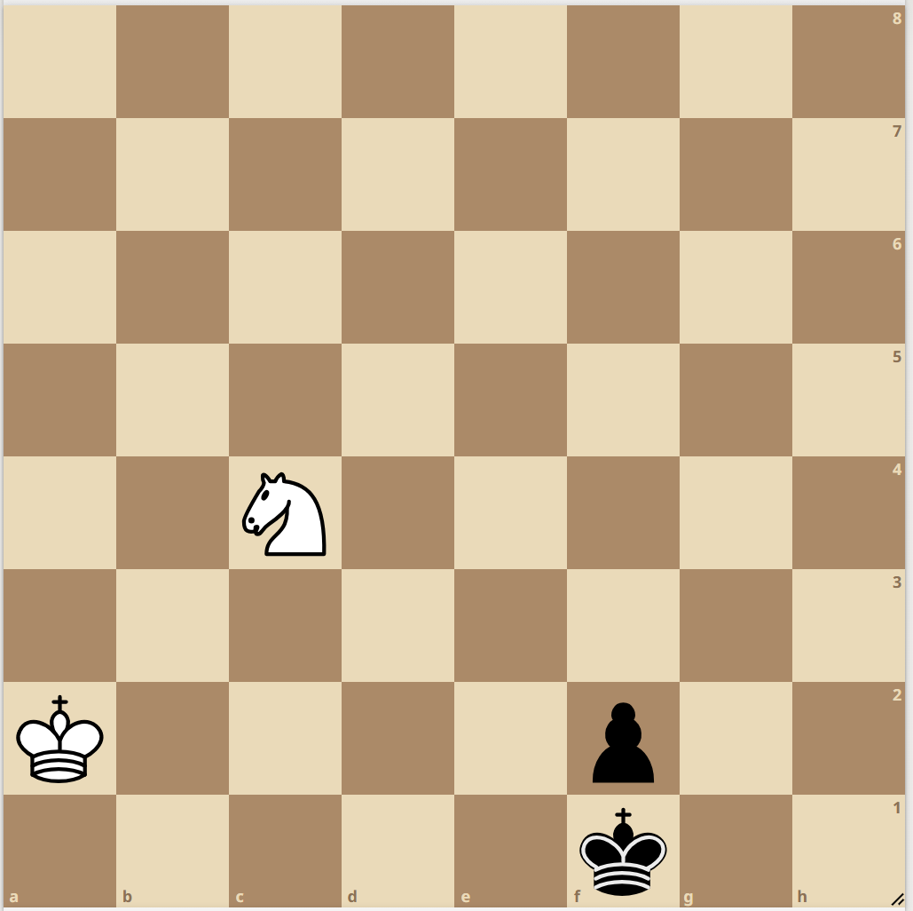 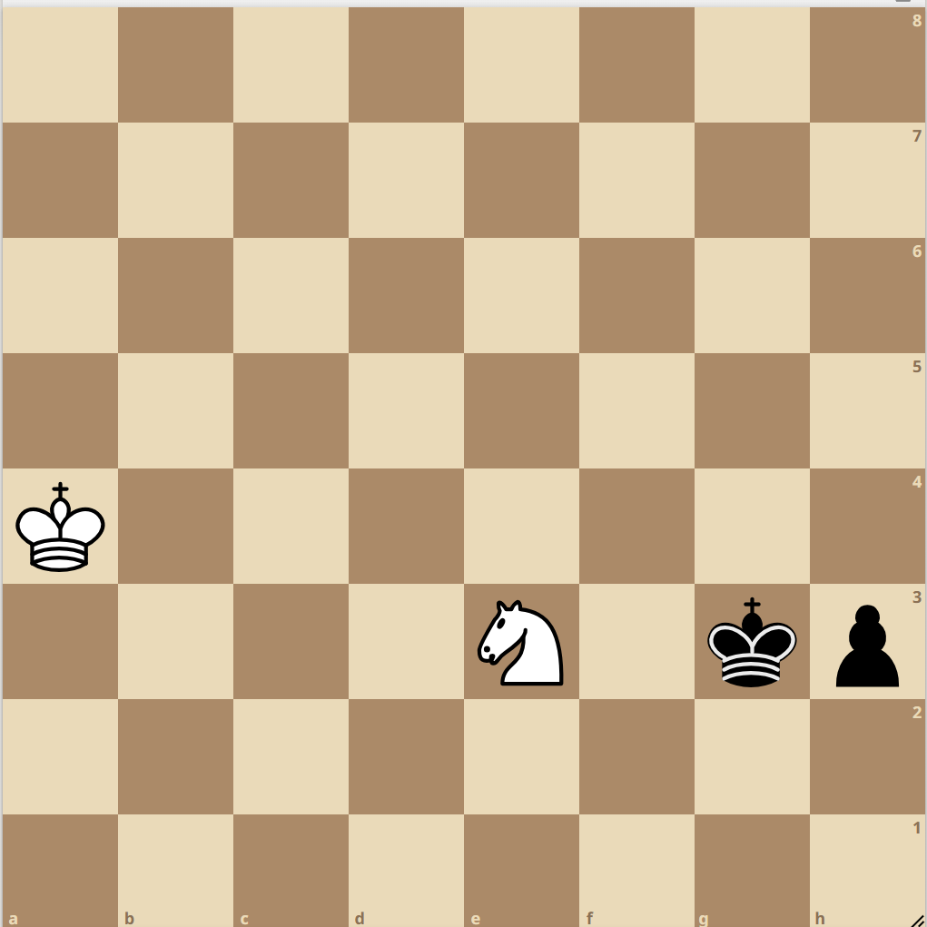

Black to play, win or draw? Black to play, win or draw?

Where is your strongside and why?

