1. 2.

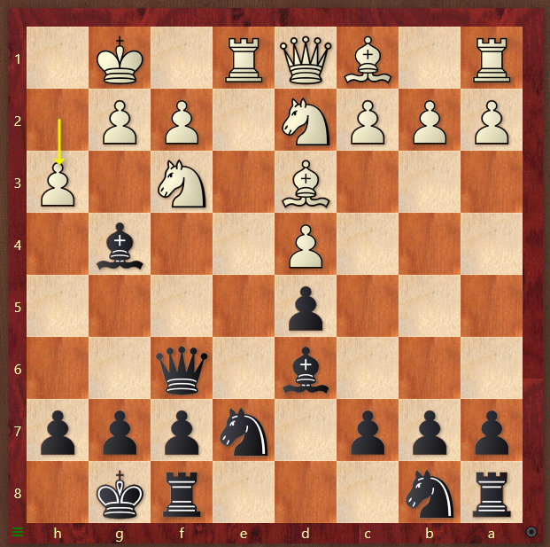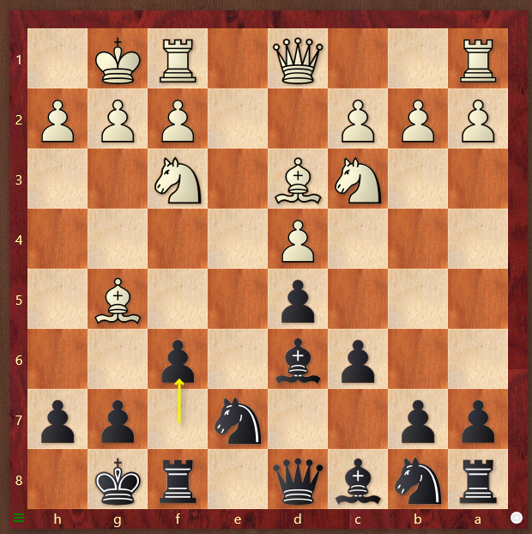

3. 4.

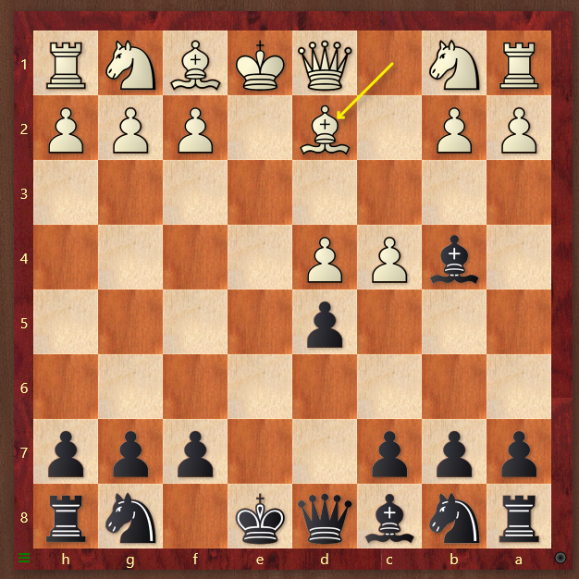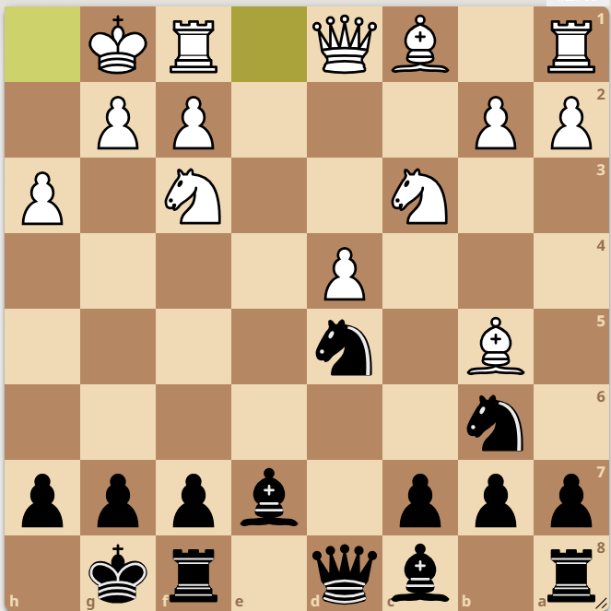

1. Should black trade bishop for knight? Yes or no and why? What is black’s strongside? What is a good 4 move plan for black?
2. After white plays Bh4, how does black get the bishop pair? What is black’s strongside? What is a good 4 move plan for black? What file should black double the rooks on?
3. Should black trade bishops? When does black capture on c4? If white doesn’t castle, how does black punish white?
4. Should black trade knights on c3? What is a good 4 move plan for black?