1. 2.

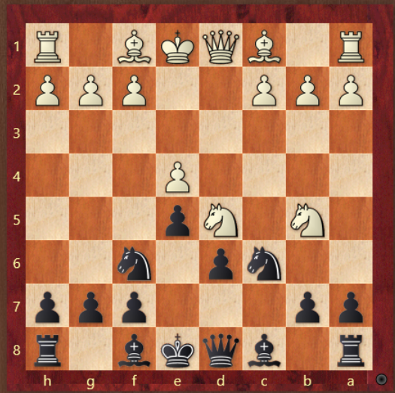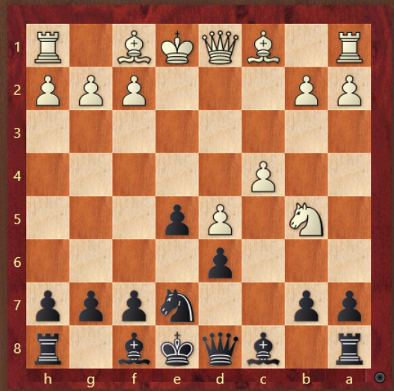

3. 4.

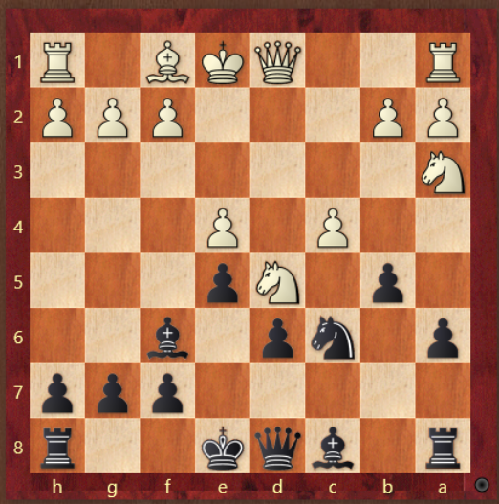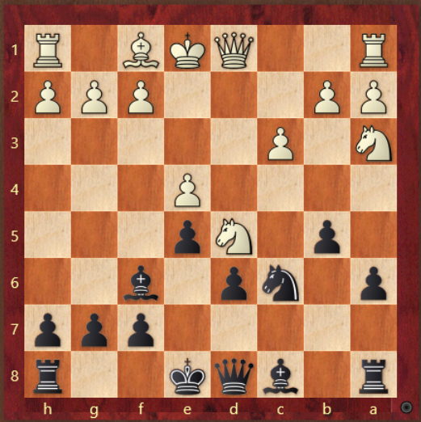

1. What is white’s threat? What should black play?

2. What is the next move for black? When do you kick white’s knight?

3.If c4 what should black do?

4. If c3 what is white trying to do? What should black do?