1. 2.

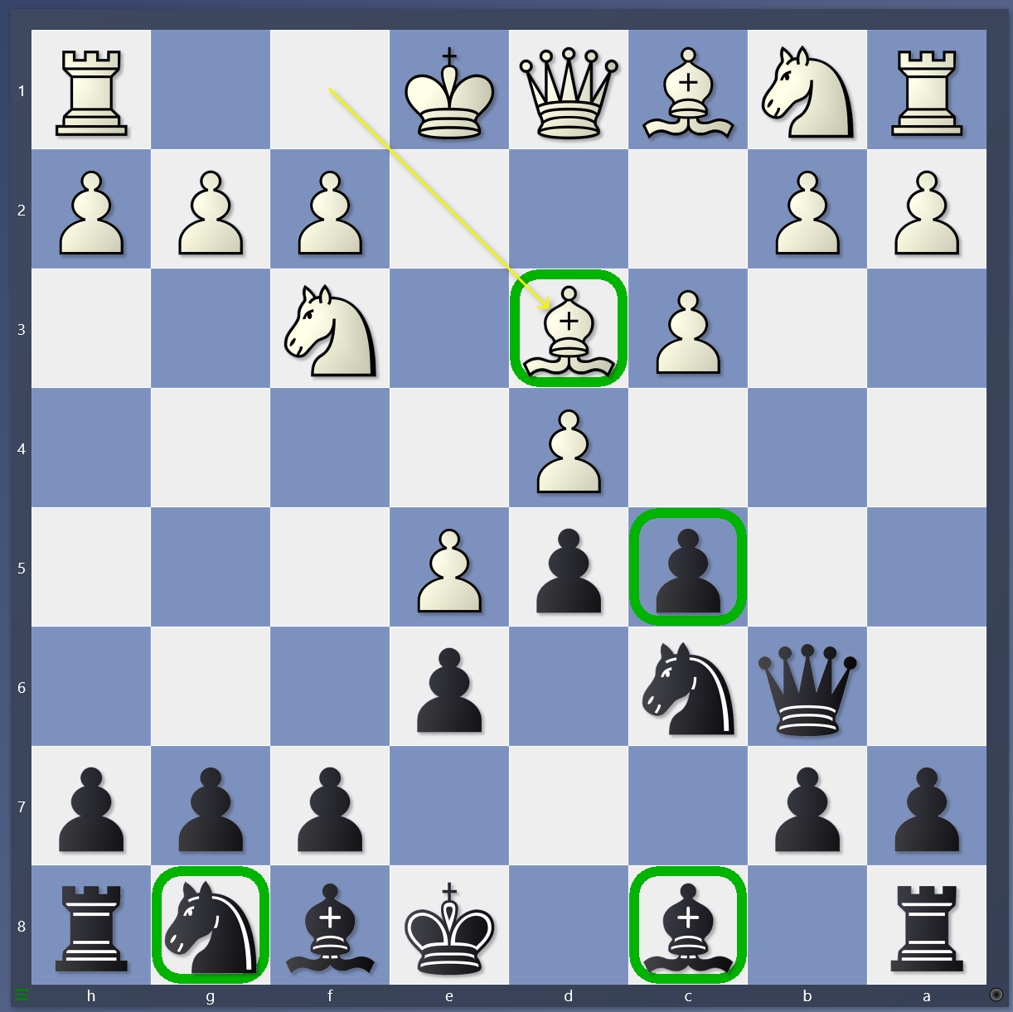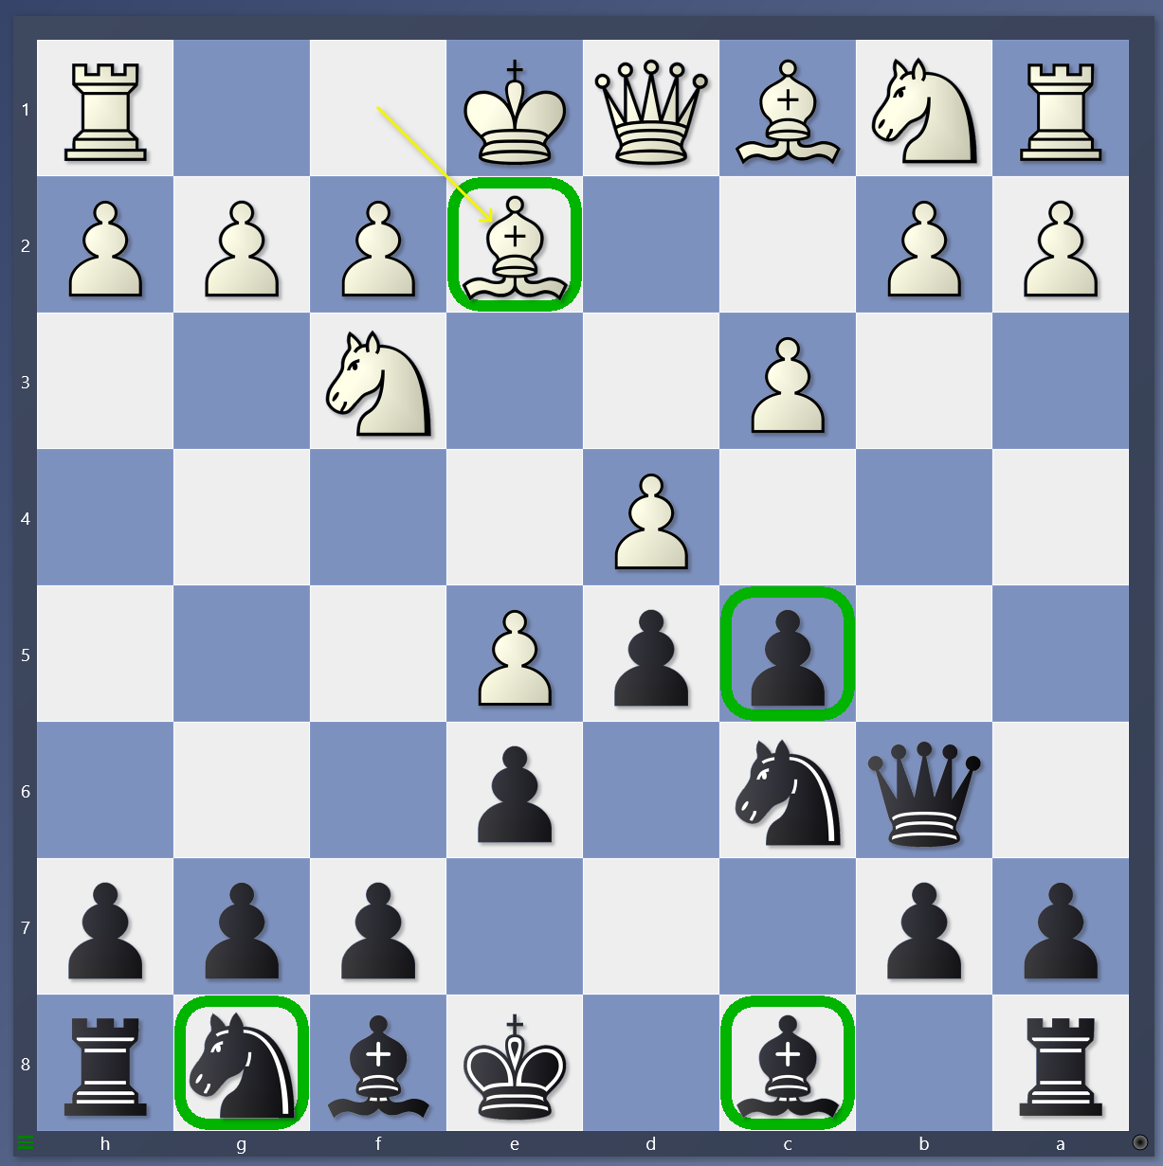

3. 4.

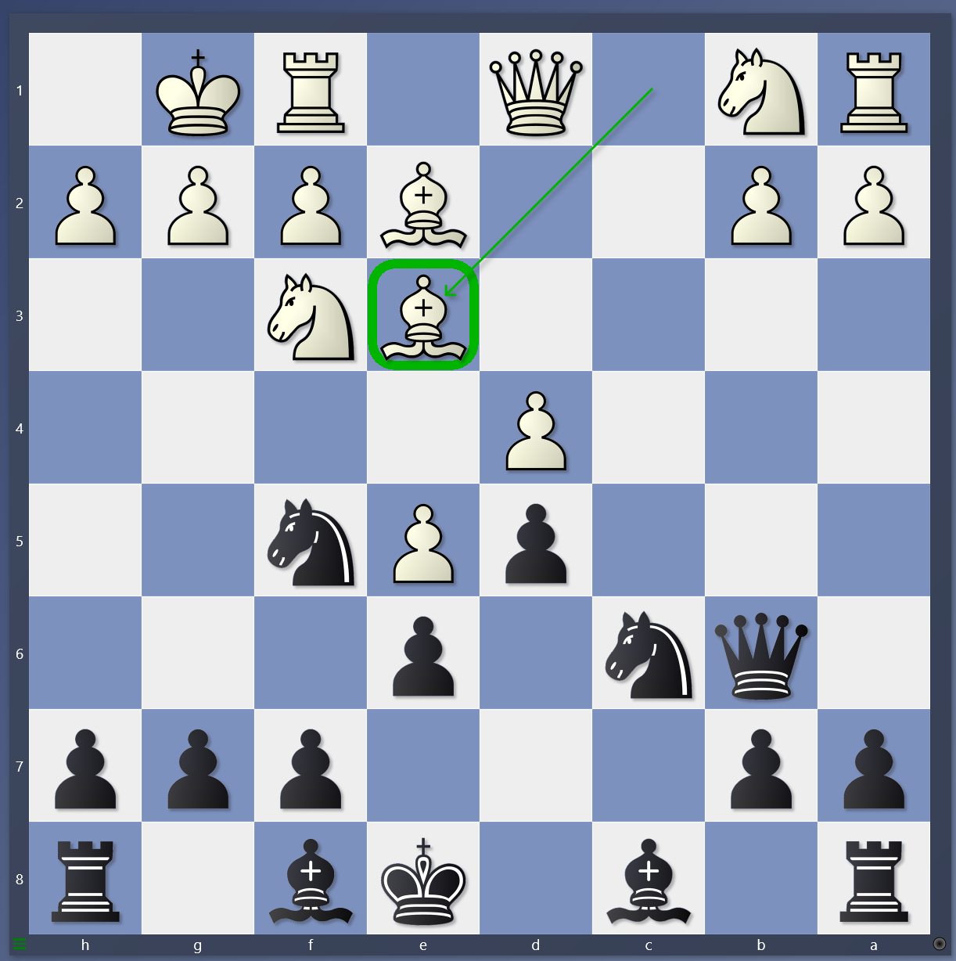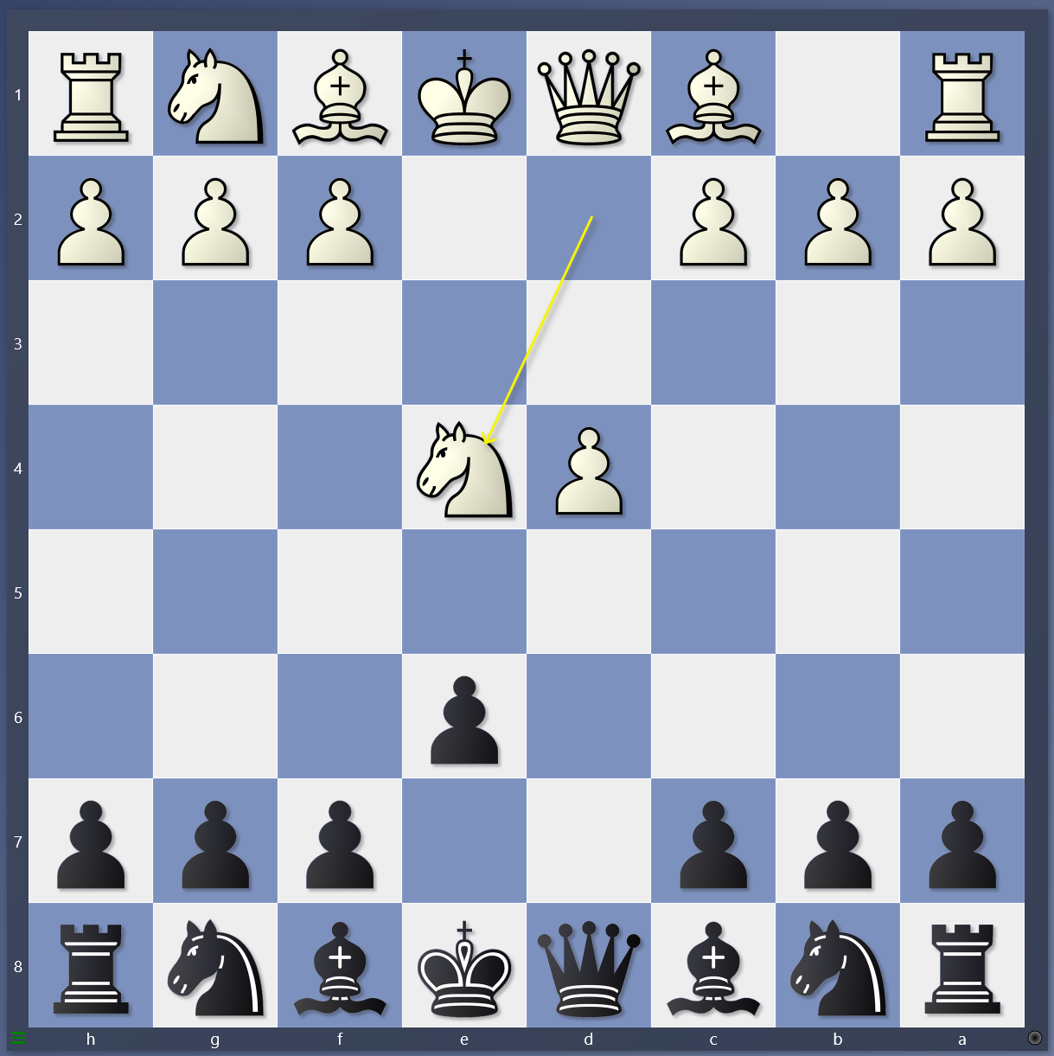

1. When does black capture the pawn on d4? What should black do if Bd3? Ne7, or Bd7? Which one and why?
2. When does black capture the pawn on d4? What should black do if Bd3? Ne7, or Bd7? Which one and why?
3. If white moves the DSB, what should black do? What are the two goals in the opening?
4. What opening is this? What is black’s next move and why?