1. 2. 3.

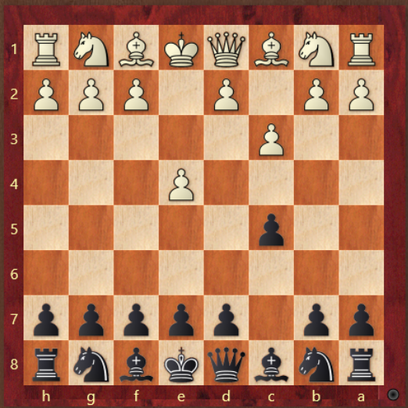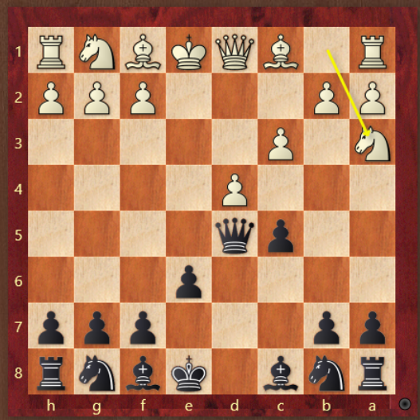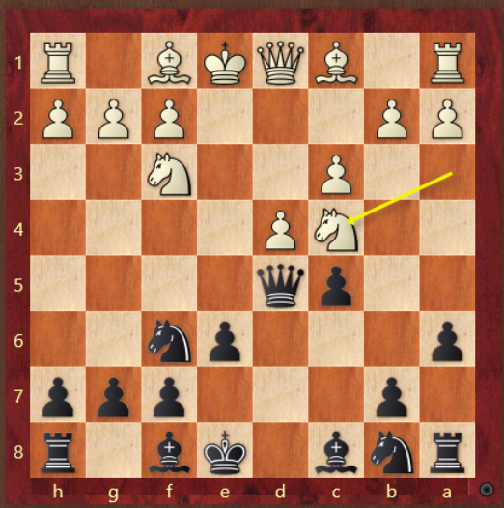

4. 5. 6.

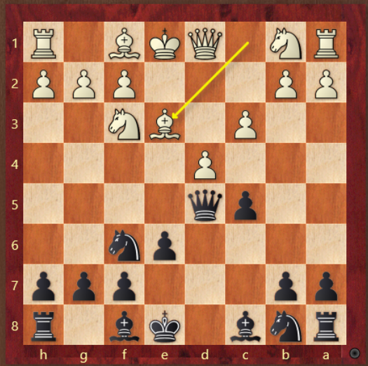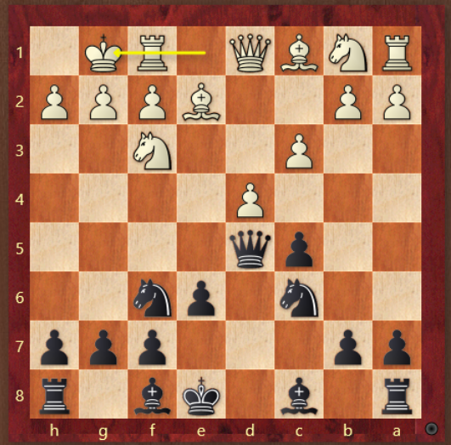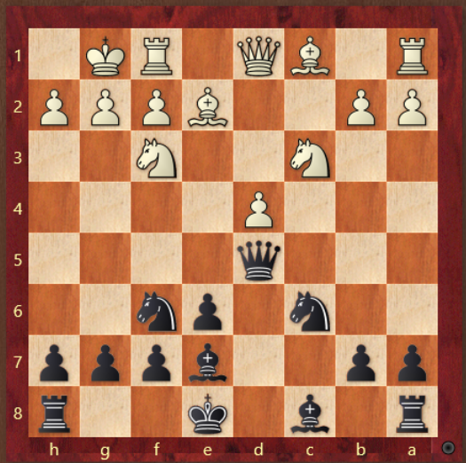

1. How does black respond to the soft Ally?
2. Na3 what is white trying to do? How does black respond?
3. Nc4, what is white trying to do? How does black respond? What is the plan?
4. If Be3, how does black respond? The key is to get the bishops.
5. If 0-0, how does black transition to a good long term advantage?
6. What is the kramnik variation here? If Nb5,Bf4 how does black parry these attacks?