1. 2. 3.

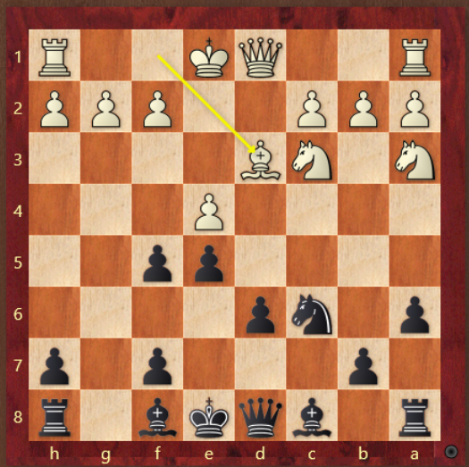 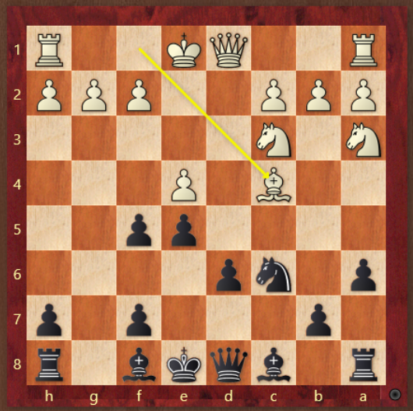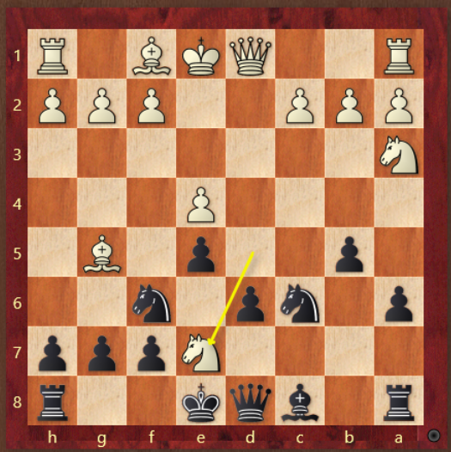

4. 5. 6.

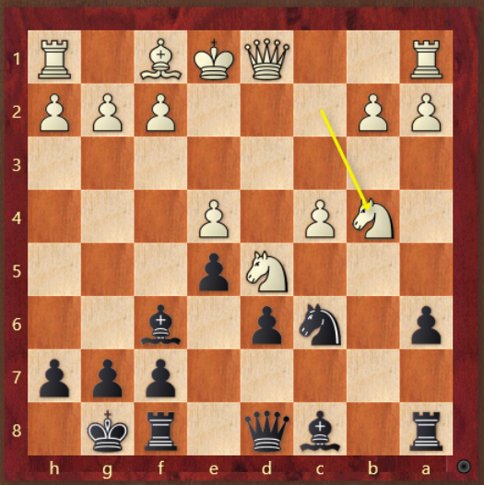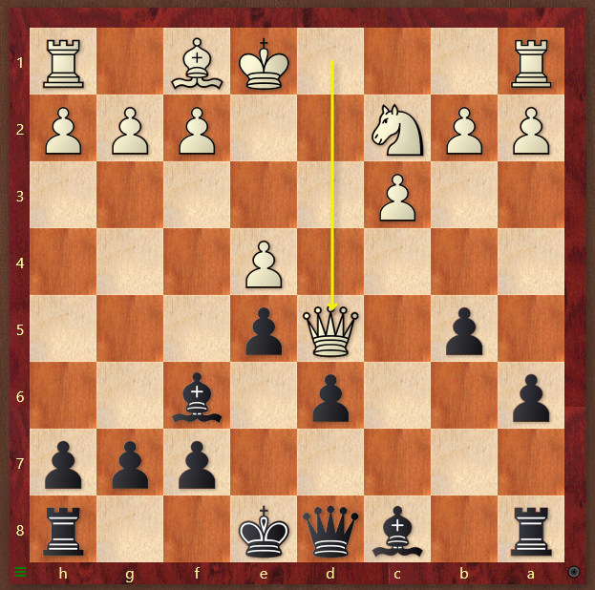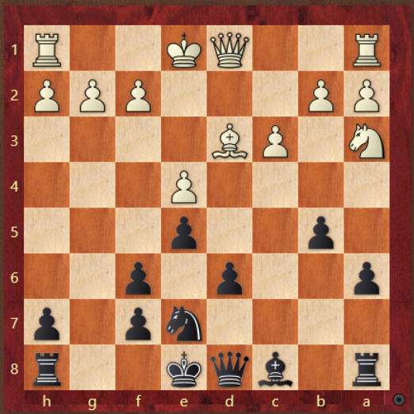

7. 8.

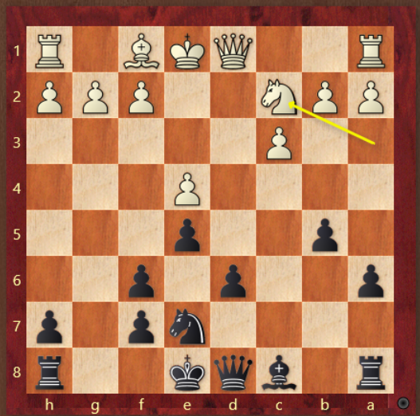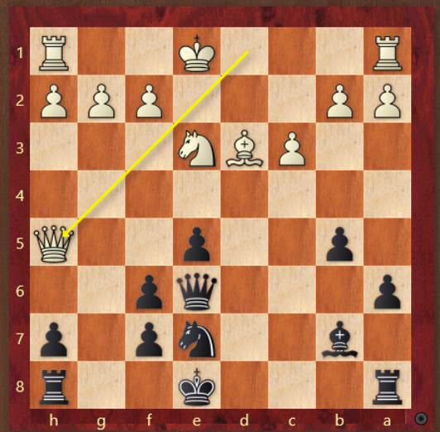

1. If Bd3, Qg5 or Rg8, which one and why? What is black’s big break after?

2. If Bc4, Qg5 or Rg8, which one and why?

3. Nxe7 or Qxe7, which one and why? What’s the plan after?

4. How does black follow up after white wins the b4 pawn?

5. What's the best move for black?

6.If Bd3 do you go Bb7 or d5?

7.If Nc2 do you go Bb7 or d5?

8.If Qh5 what is the plan for black?