1. 2.

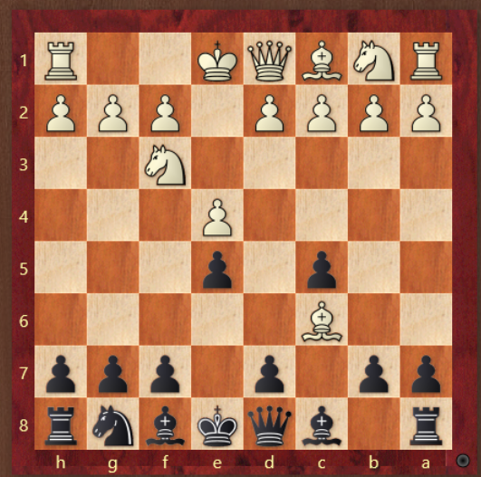 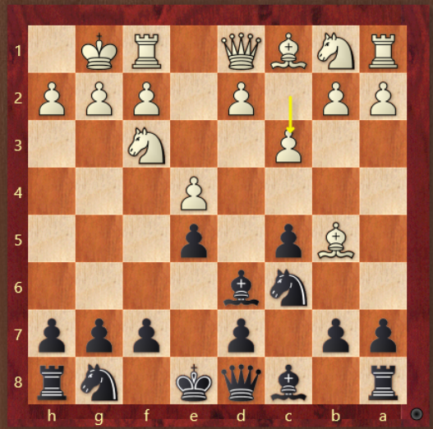

3. 4.

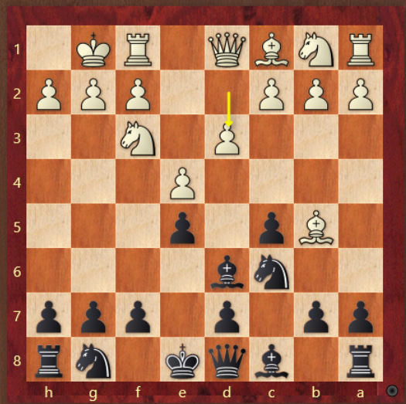 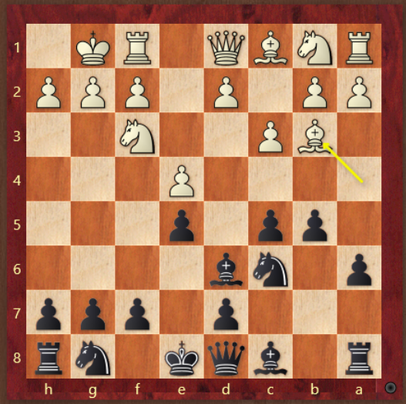

1. If white captures on c6, how do you capture back?
2. If c3 do you play Ne7 or Nf6? Do you play a6 first, or move the knight first?
3. If d3 do you play Ne7 or Nf6? Do you play a6 first, or move the knight first?
4. If Bb3 do you play c4? Instead of Bb3 if white plays Bc2 do you play c4? If Bb3 where does the knight go? If Bc2 where does the knight go?