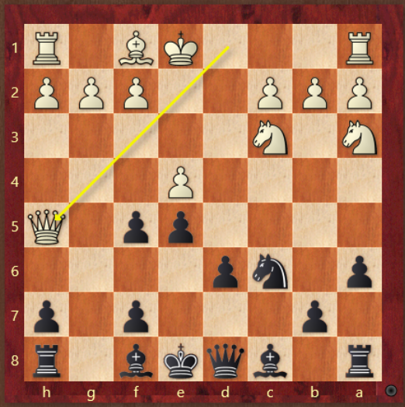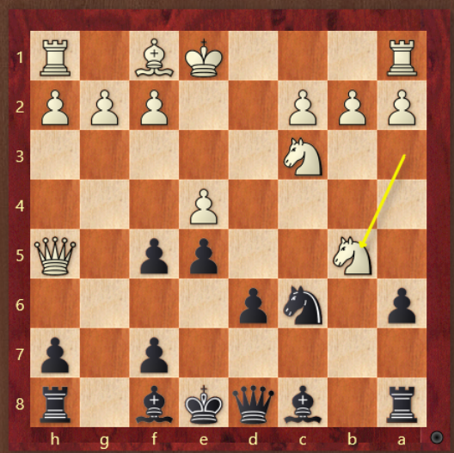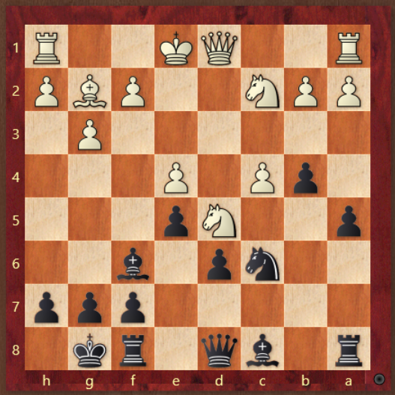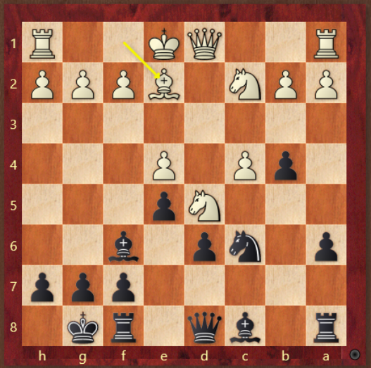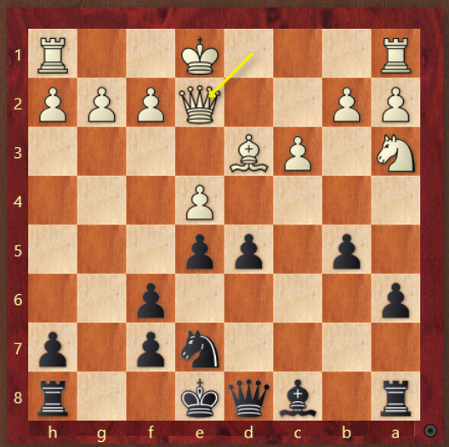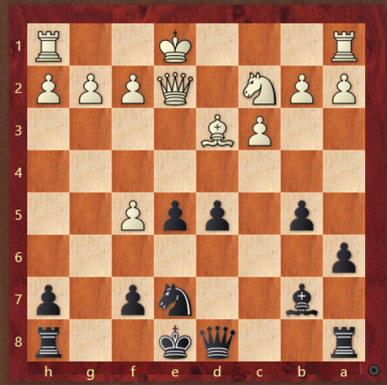

1. Qh5 is the crazy line, what should black do?
2. How does black deal with the sacrifice?
3. If g3 what is the strat?
4. If non g3 what is the strat?
5. How does black respond to Qe2?
6. Does e4 win a piece? What is the continuation?