1. 2. 3.

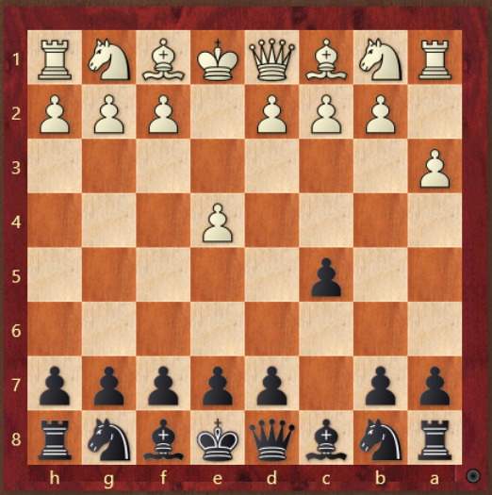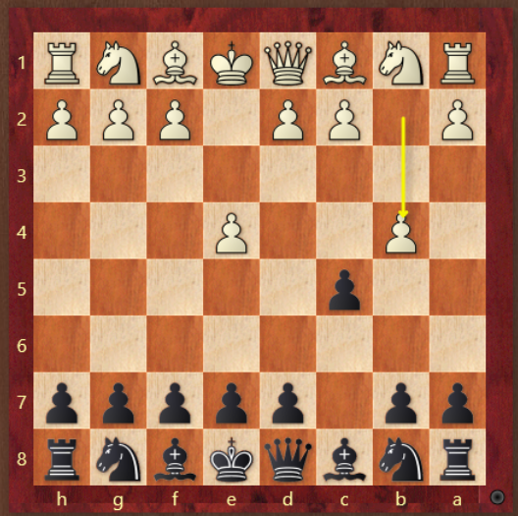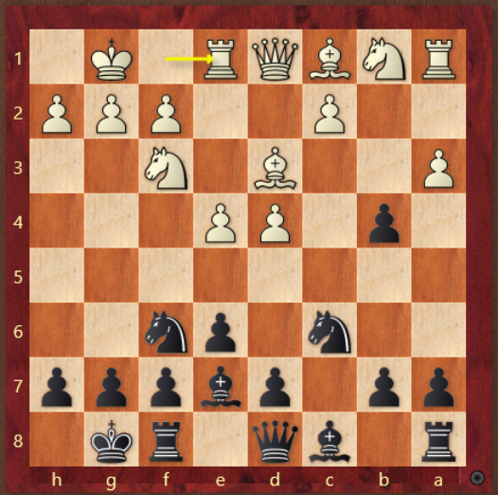

4. 5. 6.

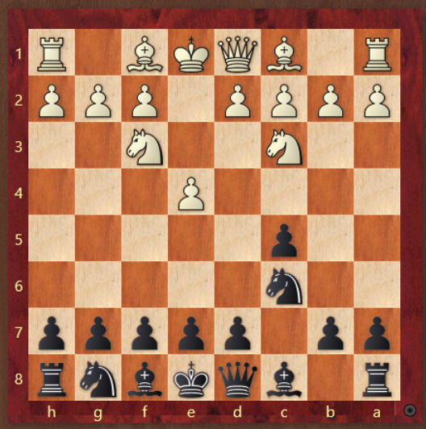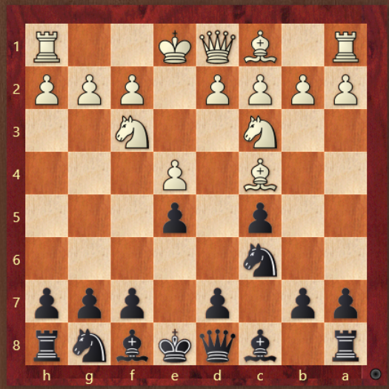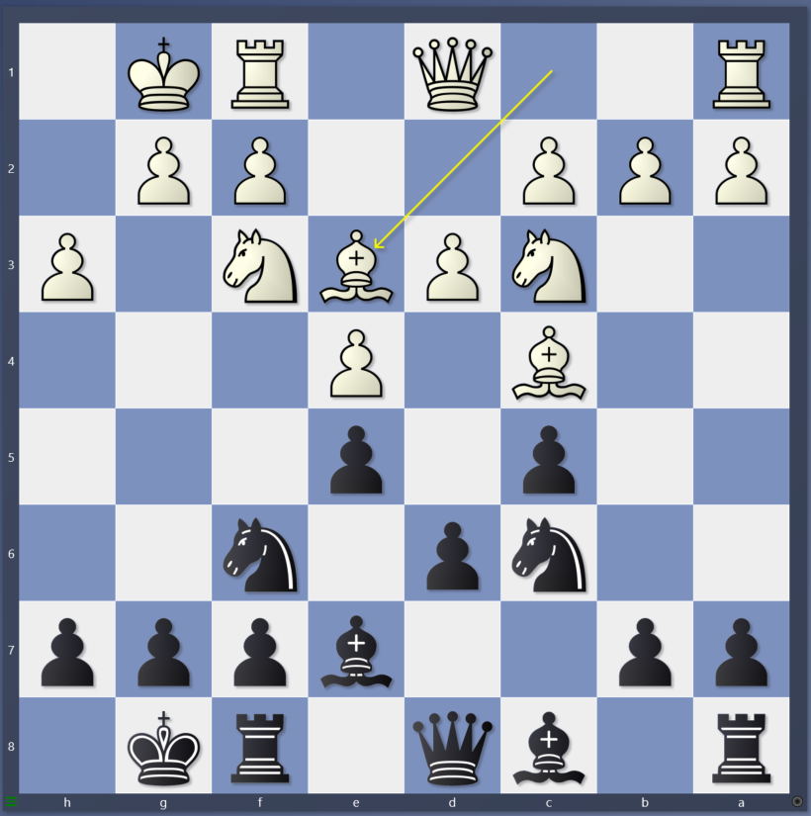

1. What does black do against this side line?
2. Does black accept the wing gambit? What is the plan for black after?
3. Does black capture the pawn on a3? What is the plan for black from here?
4. What does white do against this non open, but non closed sicil?
5. What does black have to watch out for? What should black do?
6. If you want to attack the queenside what should black do? If you want to attack the kingside what should black do?