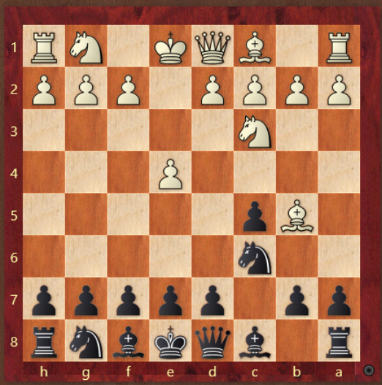 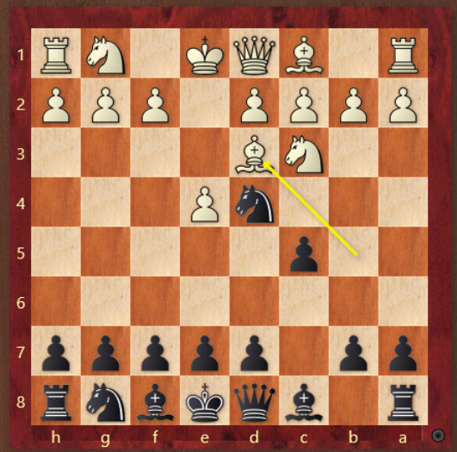

-Nd4 -g6 Bg7 normal closed sicl

-Bxc6 good rossolimo, white plays f4 in one move

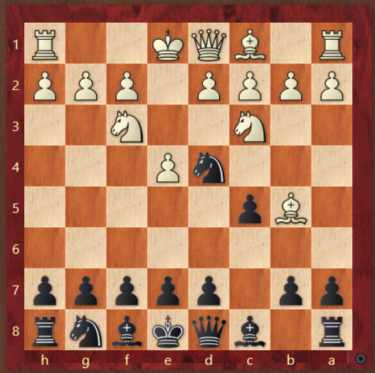 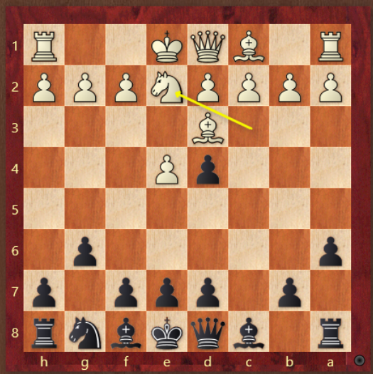

-Do NOT take the bish -Bg7 eventually d5

-a6 followed by g6-Bg7

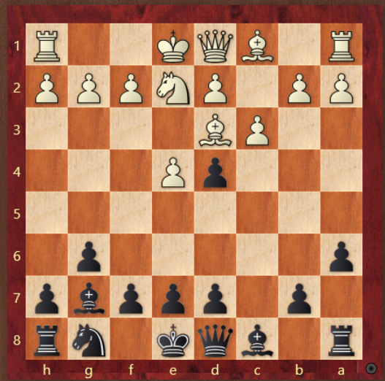 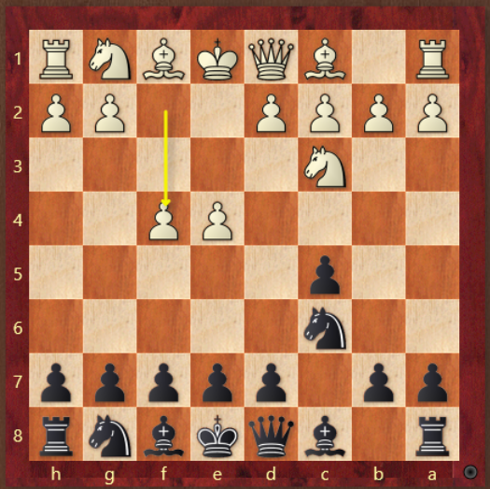

-dxc3 or e5, slight preference to e5 -Grand Prix, g6-Bg7

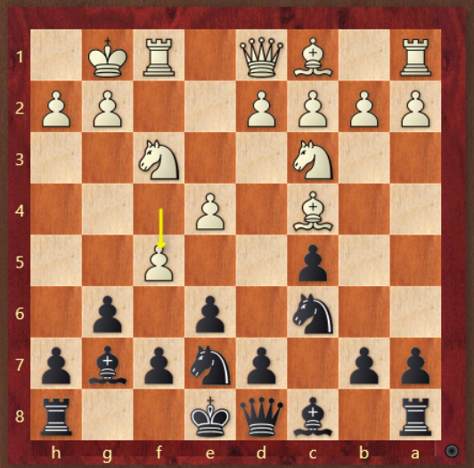 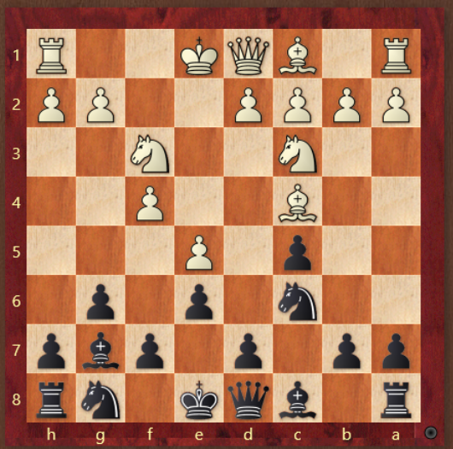

-gxf5,d5 inbetween! -Don’t allow Ne4-Nd6

-d5,Qxd6

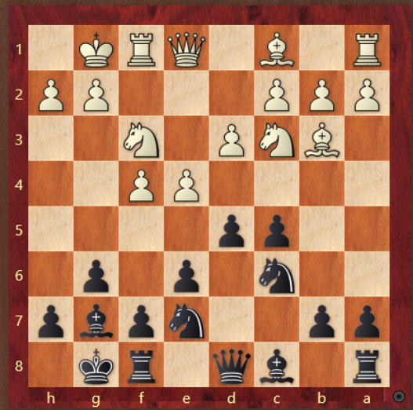 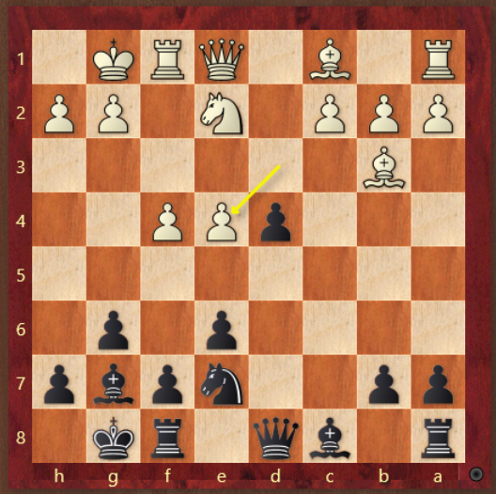

-Nd4! Always super useful -b5! Grabbing space

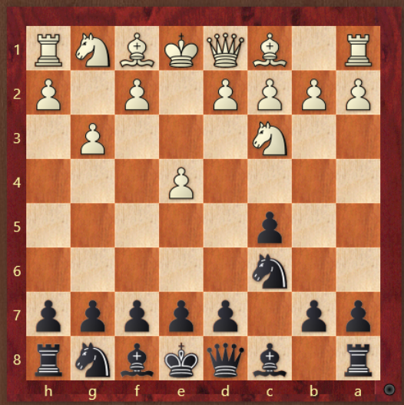 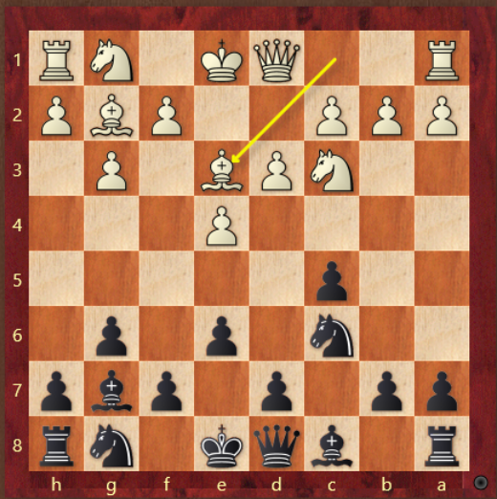

-closed sicil, g6-Bg7 -Nd4! Always useful

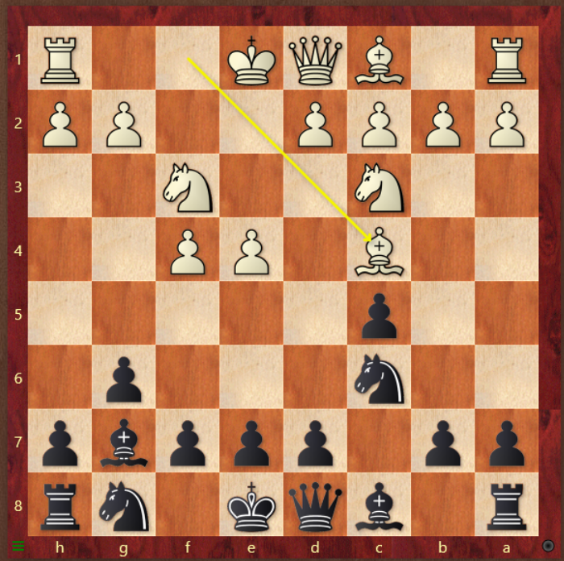

-Closed Sicil, e6,Ne7,eventually d5